NAME:

**Lesson 6.1: Absolute Value and Absolute Value Functions**



This assignment includes multiple choice and short answer questions. For multiple choice questions, select the best answer. Each is worth 1 mark. Marks assigned to short answer questions are indicated for each question. Be sure to show all necessary work.

**/1** 1. The list with values in order from least to greatest is

1. 
2. 
3. 
4. 

Answer:

**/1** 2. The winning margin between the top two candidates in an election can be represented by

1. 
2. 
3. 
4. 

Answer:

**/1** 3. The point  lies on the graph of . The corresponding point that must lie on

the graph of  is

1. 
2. 
3. 
4. 

Answer:

*Use the following information to answer question 4.*

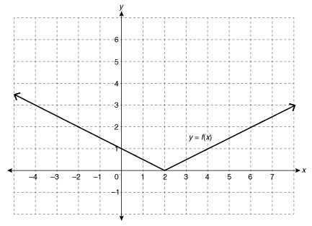

**/1** 4. The function(s) represented by the graph is/are

1.  only
2.  only
3. both  and 
4. neither  nor 

Answer:

**/1** 5. Using an example, explain how absolute value can be used to represent the distance between

two values on a number line.

Answer:

6. A hot air balloon pilot raises a balloon 200 m from the ground, turns off the burner, and

allows the balloon to descend 60 m before turning the burner on again to raise it another

170 m.

**/1** a. Use positive and negative values to represent each stage of the balloon’s flight path.  
  
 Answer:

**/1** b. Use absolute values to determine the total vertical distance travelled by the balloon.  
  
 Answer:

7. During a volleyball game, Christine dove to save a ball. The function 

approximates the height of the ball above the ground in metres, *t* seconds after it is hit.



**/1** a. If the net is 2.23 m tall, the function 

represents the distance between the bottom of the ball and the

top of the net after *t* seconds. Explain this function.  
  
 Answer:

**/1** b. Graph the absolute value function using technology.  
  
 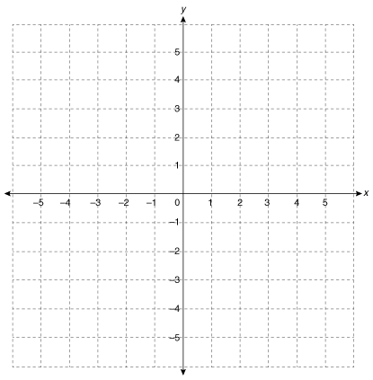

**/2** c. State the domain and range of the absolute value function.  
  
 Answer:

**/11**

You have completed *Lesson 6.1 Explore Your Understanding Assignment*. Please continue your exploration with *Lesson 6.2.*