NAME:

**Lesson 6.2: Solving Absolute Value Equations**



This assignment includes multiple choice and short answer questions. For multiple choice questions, select the best answer. Each is worth 1 mark. Marks assigned to short answer questions are indicated for each question. Be sure to show all necessary work.

**/1** 1. A partial solution to  is shown.

|  |  |
| --- | --- |
| **Line 1** |  |
| **Line 2** |  |
| **Line 3** | or |
| **Line 4** | or |

The first recorded error is in

1. Line 2
2. Line 3
3. Line 4
4. There is no error shown.

Answer:

**/1** 2. The absolute value equation with exactly one solution is

1. 
2. 
3. 
4. 

Answer:

*Use the following information to answer question 3.*

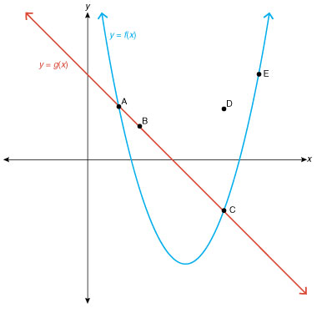

**/1** 3. The solutions to the equation are represented by the points

1. A and B
2. A and C
3. A and E
4. A, B, D, and E

Answer:

**/1** 4. The solution to  can be found by

1. solving  over the interval .
2. solving  over the interval .
3. solving  over the interval .
4. solving  over the interval .

Answer:

**/1** 5. The maximum and minimum length, *l*, of an 8 ft board with a tolerance of  in can be

determined by solving the equation

1. 
2. 
3. 
4. 

Answer:

**/3** 6. Solve  algebraically.

Answer:

**/2** 7. An equation that describes the maximum and minimum temperatures at which a chemical

compound is in a liquid state is given by the absolute value equation , where *T* is

the temperature in degrees Celsius. Calculate the range in temperature, and identify the chemical compound.

Answer:

**/10**

You have completed *Lesson 6.2 Explore Your Understanding Assignment*. Please continue your exploration with *Lesson 6.3.*