NAME:

**Lesson 6.3: Reciprocal Functions**



This assignment includes multiple choice and short answer questions. For multiple choice questions, select the best answer. Each is worth 1 mark. Marks assigned to short answer questions are indicated for each question. Be sure to show all necessary work.

**/1** 1. If the point  lies on the graph of , then the graph of includes the

point

1. 
2. 
3. 
4. 

Answer:

*Use the following information to answer question 2.*

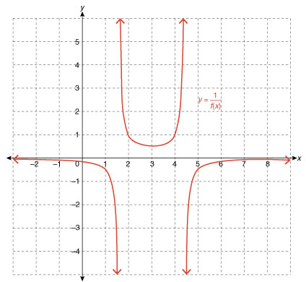

**/1** 2. The range of  is

1. 
2. 
3. 
4.   
     
   Answer:

**/1** 3. If , then the domain of  is

1. 
2. 
3. 
4.   
     
   Answer:

**/1** 4. The graph of  has _*A*_ horizontal asymptotes, _*B*_ vertical asymptotes, and the

graphs of the functions  and  will intersect _*C*_ times. The values

of *A*, *B*, and *C* are ______.

**/2** 5. Sketch the graph of , outlining the steps used.  
 

**/2** 6. Use the graph of  to graph .  
 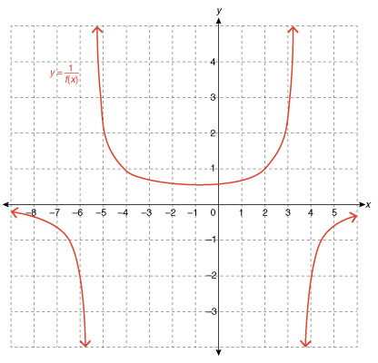

**/8**

You have completed *Lesson 6.3 Explore Your Understanding Assignment*. Please proceed to the

*Unit 6: Absolute Value and Reciprocal Function Final Review Assignment.*