NAME:

**Lesson 7.1: Solving Systems of Equations Graphically**



This assignment includes multiple choice and short answer questions. For multiple choice questions, select the best answer. Each is worth 1 mark. Marks assigned to short answer questions are indicated for each question. Be sure to show all necessary work.

**/1** 1. The *x*-value of a solution to the system  and  is

1. 6
2. 2.5
3. 1
4. –4.5

Answer:

**/1** 2. The system of equations  and  will have

1. 1 solution
2. 2 solutions
3. no solutions
4. an infinite number of solutions

Answer:

*Use the following diagram to answer question 3.*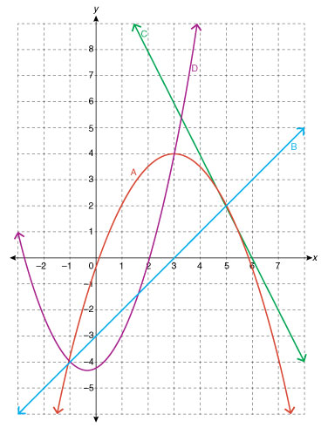

**/1** 3. A system of quadratic-linear equations whose only solution is (5, 2) can be formed using

lines

1. A and B
2. A and C
3. B and C
4. C and D

Answer:

**/2** 4. Solve the following system graphically. Verify the solution(s) using substitution.

* 
* 

Answer:

**/2** 5. As part of a fountain display, two jets of water travel from the surface of an upper pool and

meet at the surface of a lower pool, as shown in the diagram. The paths of the two jets are

modelled by  and , where *x* and *y* are measured in feet. What is

the vertical height difference, *d*, of the pools? Round the answer to the nearest hundredth.  
 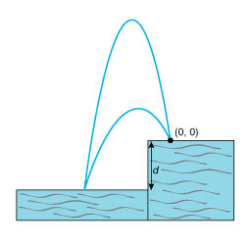

Answer:

**/7**

You have completed *Lesson 7.1 Explore Your Understanding Assignment*. Please continue your exploration with *Lesson 7.2.*