NAME:

**Lesson 7.3: Linear Inequalities in Two Variables**



This assignment includes multiple choice and short answer questions. For multiple choice questions, select the best answer. Each is worth 1 mark. Marks assigned to short answer questions are indicated for each question. Be sure to show all necessary work.

**/1** 1. The ordered pair that **does not** belong to the solution set of the inequality  is

1. (1, 1)
2. (2, 3)
3. (1, –4)
4. (–3, –3)

Answer:

**/1** 2. The graph that matches the inequality  is

1. 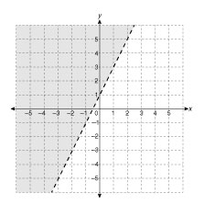
2. 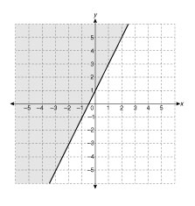
3. 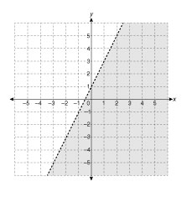
4. 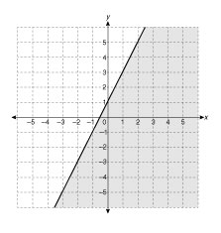

Answer:

**/1** 3. Consider the inequality . The point (2, 1) is in the solution region when

1. 
2. 
3. 
4.   
     
   Answer:

**/2** 4. Gary is a fitness trainer who makes 30 and 45 minute appointments

with clients. Gary’s contract allows him to make up to 30 hours of

appointments in a week. State the inequality that represents all the

possible combinations of appointments that Gary can make in a

week. Graph the inequality.



**/5**

You have completed *Lesson 7.3 Explore Your Understanding Assignment*. Please continue your exploration with *Lesson 7.4.*