**Practice Assessment**

*Practice* provides practice and allows you to self-reflect on your conceptual understanding of the *Lesson* skills. You will mark your work for *Practice* in each Workbook according to the following rubric.

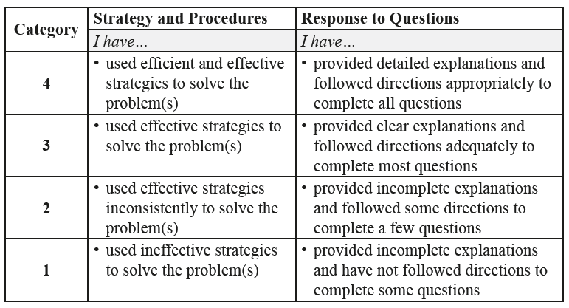

Complete *Practice* exercises using your best work, showing all relevant steps needed to arrive at your solution. Refer to the *Module* to review lesson instructions. Contact your teacher for assistance

or clarification as needed, or to investigate the topic further.

Check and correct your work using the solutions provided by the answer key.

*Practice* is worth 8 marks; your mark can help you gauge your understanding of *Lesson* material.

After you have assessed your work, reflect on your understanding of the concepts addressed in the *Practice* exercises in the table provided.

NAME:

Self-assessed mark: /8

**Lesson 7.4: Quadratic Inequalities in One Variable**

Complete the *Practice* below. When you have completed all the questions for *Lesson 7.4 Practice – V* with your best work, mark your work by first comparing your answers to the solutions provided by the answer key. Then, apply the rubric found at the beginning of the *Practice*.



1. Solve  using sign analysis. Represent the solution set symbolically and on a number line.  
     
   Answer:
2. The ‘case analysis’ method for solving a quadratic inequality is shown on p. 479 of   
   *Pre-Calculus 11*.
   1. Explain the case analysis strategy.  
        
      Answer:
   2. Describe how the case analysis strategy is similar to the sign analysis strategy.  
        
      Answer:
   3. Solve  using the case analysis strategy.

1. A golfer makes a chip shot that travels 40 feet over flat terrain before landing. If the ball follows a parabolic path, and the maximum height reached by the ball is 33 feet, during what interval is the ball above 25 feet?  
     
   Answer:

Mark your work for *Lesson 7.4 Practice – V* using the solutions provided in the *Unit* *Resources* Folder at the bottom of the online *Table of Contents* for this *Unit.* Then, apply the rubric found at the beginning of the *Practice*.

Transfer your self-assessed mark to the beginning of the *Practice*.

Reflect on your understanding of the concepts addressed in the *Practice* exercises in the table provided.

|  |  |  |  |  |
| --- | --- | --- | --- | --- |
| Question Number | Got it! | Almost there… | Need to retry or ask for help. | Similar questions from  *Pre-Calculus 11* |
| 1 |  |  |  | p.485 #5ac |
| 2 |  |  |  | p.485 #6ab |
| 3 |  |  |  | p.485 #11 |

You may proceed to *Explore Your Understanding Assignment*.

**Note:** Before you complete *Explore Your Understanding*, you may review your skills and get more practice by completing the following problems in *Pre-Calculus 11*.

* Page 484 #1, 2, 4ac, 5ac, 6ab, 7ab, and 11

Check your work in the *Unit Resources* folder at the end of the *Unit* of the online course.