NAME:

**Lesson 7.4: Quadratic Inequalities in One Variable**

****

This assignment includes multiple choice and short answer questions. For multiple choice questions, select the best answer. Each is worth 1 mark. Marks assigned to short answer questions are indicated for each question. Be sure to show all necessary work.

**/1** 1. The solution to is

C:\Documents and Settings\Administrator\Desktop\7_4_Exp_1a.jpg

1. C:\Documents and Settings\Administrator\Desktop\7_4_Exp_1b.jpg
2. C:\Documents and Settings\Administrator\Desktop\7_4_Exp_1c.jpg
3. C:\Documents and Settings\Administrator\Desktop\7_4_Exp_1d.jpg

Answer:

*Use the following graph to answer question 2.*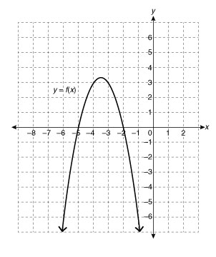

**/1** 2. The solution to  is

1. 
2. 
3. 
4. 

Answer:

*Use the following diagram to answer question 3.*

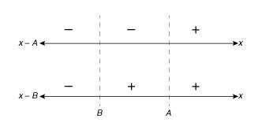

**/1** 3. The solution to  is

1. 
2. 
3. 
4. 

Answer:

**/1** 4. If  and , the solution to the inequality  will cover more of the number

line when

1. *r* is increased
2. *r* is decreased
3. *s* is increased
4. *s* is decreased

Answer:

**/2** 5. Solve the inequality .

Answer:

**/2** 6. The kinetic energy of a moving object is related to its mass and velocity by the formula   
 , where *Ek* is the kinetic energy in joules, *m* is the mass of the object in kilograms,   
 and *v* is the object’s velocity in metres per second. What are the possible velocities for a 3 kg  
 object with a kinetic energy of less than 600 J? (Negative velocities are acceptable and   
 represent the opposite direction of a positive velocity.

Answer:

**/8**

You have completed *Lesson 7.4 Explore Your Understanding Assignment*. Please proceed to *Lesson 7.5*.