**Practice Assessment**

*Practice* provides practice and allows you to self-reflect on your conceptual understanding of the *Lesson* skills. You will mark your work for *Practice* in each Workbook according to the following rubric.

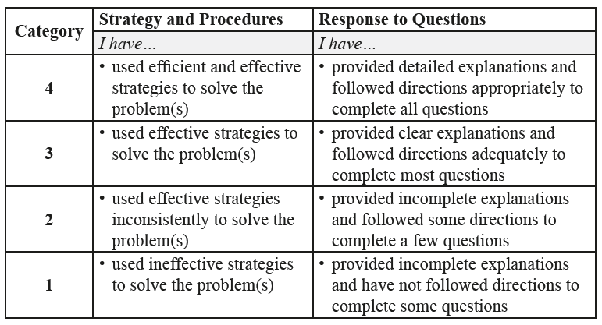

Complete *Practice* exercises using your best work, showing all relevant steps needed to arrive at your solution. Refer to the *Module* to review lesson instructions. Contact your teacher for assistance or clarification as needed, or to investigate the topic further.

Check and correct your work using the solutions provided by the answer key.

*Practice* is worth 8 marks; your mark can help you gauge your understanding of *Lesson* material.

After you have assessed your work, reflect on your understanding of the concepts addressed in the *Practice* exercises in the table provided.

NAME:

Self-assessed mark: /8

**Lesson 7.5: Quadratic Inequalities in Two Variables**

Complete the *Practice* below. When you have completed all the questions for *Lesson 7.5 Practice – VI* with your best work, mark your work by first comparing your answers to the solutions provided by the answer key. Then, apply the rubric found at the beginning of the *Practice*.



1. Determine if the point (5, 17) is a solution to .  
     
   Answer:
2. Graph the inequality.  
   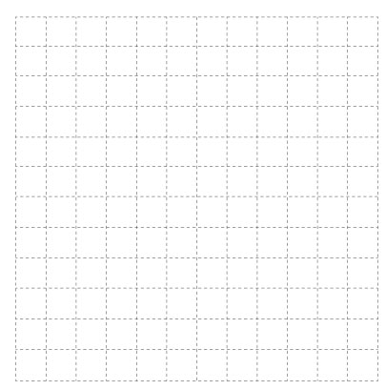

Answer:

1. Write an inequality to represent the given graph.

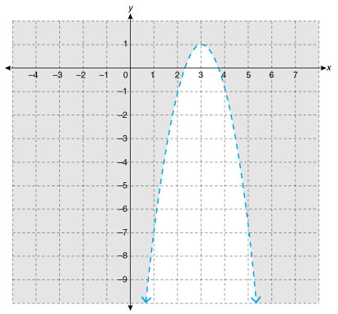  
  
Answer:

1. Suppose the points (3, 0) and (5, 0) are solutions to a quadratic inequality, but the point (4, 0) is not. Describe how the direction of opening of the parabolic boundary can be determined.

Answer:

1. Use technology to graph the solution to .  
     
   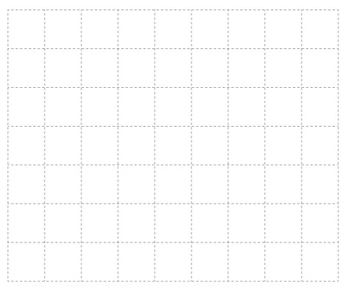  
     
   Answer:  
     
     
     
     
     
     
   
2. In one type of solar thermal power station, an array of parabolic troughs focuses sunlight onto a pipe to heat steam inside. The troughs are rotated throughout the day, so they always directly face the sun. Describe the region of sunlight captured by a trough with a width of 6 m and a maximum depth of 1 m.  
     
   Answer:

Mark your work for *Lesson 7.5 Practice – VI* using the solutions provided in the *Unit* *Resources* Folder at the bottom of the online *Table of Contents* for this *Unit.* Then, apply the rubric found at the beginning of the *Practice*.

Transfer your self-assessed mark to the beginning of the *Practice*.

Reflect on your understanding of the concepts addressed in the *Practice* exercises in the table provided.

|  |  |  |  |  |
| --- | --- | --- | --- | --- |
| Question Number | Got it! | Almost there… | Need to retry or ask for help. | Similar questions from  *Pre-Calculus 11* |
| 1 |  |  |  | p.496 #1b |
| 2 |  |  |  | p.497 #4b, 5c |
| 3 |  |  |  | p.497 #3 |
| 4 |  |  |  |  |
| 5 |  |  |  | p.497 #7ac |
| 6 |  |  |  | p.498 #10 |

You may proceed to *Explore Your Understanding Assignment*.

**Note:** Before you complete *Explore Your Understanding*, you may review your skills and get more practice by completing the following problems in *Pre-Calculus 11*.

* Page 496 #1b, 3, 4b, 5c, 7ac, and 10

Check your work in the *Unit Resources* folder at the end of the *Unit* of the online course.