NAME:

**Lesson 7.5: Quadratic Inequalities in Two Variables**



This assignment includes multiple choice and short answer questions. For multiple choice questions, select the best answer. Each is worth 1 mark. Marks assigned to short answer questions are indicated for each question. Be sure to show all necessary work.

**/1** 1. The solution set of the inequality  includes the points

1. (–1, 1), (4, 0), and (7, –1)
2. (1, 3), (4, 1), and (8, 2)
3. (4, 2), (7, 4), and (8, 8)
4. (–4, 2), (0, 9), and (9, 1)

Answer:

**/1** 2. The points (3, 8), and (6, 8) are part of the solution set of a quadratic inequality, while   
 (5, 9), and (7, 7) are not. The point that must also be part of the solution set is

1. (4, 7)
2. (4, 9)
3. (8, 6)
4. (6, 10)

Answer:

**/1** 3. The wording that implies a strict inequality is

1. The diameter can be a maximum of...
2. Acceptable values cannot exceed...
3. The profit was at least...
4. The ball was below...

Answer:

**/1** 4. Consider the inequality , where . No new solutions will be added to the   
 solution set when

1. *a* is increased
2. *a* is decreased
3. *h* is increased
4. *h* is decreased

Answer:

**/2** 5. Graph the inequality .  
  
 

1. 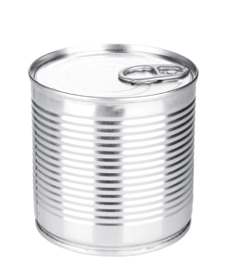Modern metal cans, like the one shown, are usually made from steel, and then covered with a thin layer of tin.

**/1**  a. Write an inequality representing the amount of sheet metal that can be used to

make a can that is 10 cm tall.

Answer:

**/1**  b. Graph the inequality.

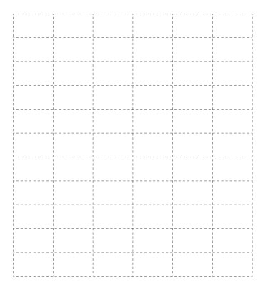

**/1**  c. Explain how the graph can be used to determine the minimum amount of metal required for

cans of various radii.  
  
 Answer:  
  
  
  
  
  
  
  
  
 d. Solving this problem using the formula for the surface area of a cylinder is not completely

accurate.

**/0.5** i. Explain a factor that the surface area of a cylinder does not account for.  
  
 Answer:

**/0.5** ii. Suggest a change to a surface area of a cylinder inequality that would make it more

accurately represent the amount of metal required to make a tin can like the one

shown.  
  
 Answer:

**/10**

You have completed *Lesson 7.5 Explore Your Understanding Assignment*. Please proceed to the *Unit 7: Equations and Inequalities Final Review Assignment.*