NAME:

**Unit 7: Equations and Inequalities**



This assignment includes multiple choice and short answer questions. For multiple choice questions, select the best answer. Each is worth 1 mark. Marks assigned to short answer questions are indicated for each question. Be sure to show all necessary work.

**/1**____1. The *x*-value(s) of the solution(s) to the system  and  is/are

A. –1

B. 8

C. –1 and 6

D. 8 and 29

Answer:

*Use the following information to answer question 2.*

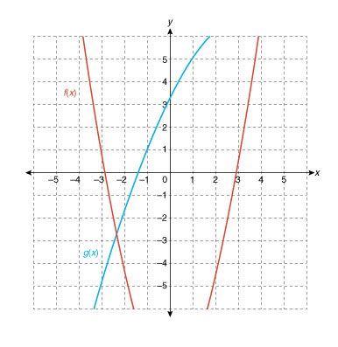

**/1**____2. If there are no restrictions on the domain, this quadratic system has

A. 0 solutions

B. 1 solution

C. 2 solutions

D. an infinite number of solutions

Answer:

**/1___** 3. If (3, 6) lies on the boundary of the inequality , the point that must be a solution to   
 the inequality is

A. (0, 6)

B. (3, 3)

C. (3, 9)

D. (6, 6)

Answer:

**/1___** 4. The boundary of a linear inequality is . The coordinates (2, 3) satisfies the   
 inequality, so

A. a dashed line will represent the boundary, but the solution region is unknown

B. a solid line will represent the boundary, but the solution region is unknown

C. the boundary line type is unknown, but the solution region is above the boundary

D. the boundary line type is unknown, but the solution region is below the boundary

Answer:

**/1___** 5. The inequality  has an infinite number of real solutions when

A. 

B. 

C. 

D. 

Answer:

**/1** 6. Write a quadratic inequality that has the solution  or .

Answer:

**/2** 7. A rubber ball is thrown upward with an initial speed of 20 m/s. The approximate height of   
 the ball after *t* seconds is . Determine the time period, to the nearest   
 hundredth of a second, during which the ball is higher than 8 m.

Answer:

1. 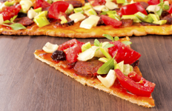A pizzeria is putting on a ‘pie-by-length’ event where customers can order a rectangular pizza that is 6” wide by the length of their choice. Customers can also order circular pizzas of several diameters.

**/1** a. Solving the equation  will give the length/diameter where   
 the two shapes have the same area. Explain how this formula was determined.

Answer:

**/2** b. For what length/diameter will the two shapes of pizza have the same area? Round the answer   
 to the nearest tenth of an inch.

Answer:

**/1** c. The pizzeria owner says that when customers order pie-by-length, they feel like they are   
 getting more for less. How might he justify this claim?

Answer:

1. A clothing store is holding a ‘buy one, get one half off’ sale for t-shirts, where the second t-shirt purchased is half the original price.

**/2** a. Let *b* be the cost to the store to buy the shirts, and let *s* be the original   
 selling price. Write an inequality relating the two variables such that the store profits more   
 from a customer purchasing two t-shirts than from a customer purchasing one. (Hint: The   
 expression *s – b* represents the profit when one shirt is purchased. What is an expression for the   
 profit when two shirts are purchased?)

Answer:

**/1** b. Isolate *b* in the inequality. Explain what the inequality says about the buying and selling   
 prices.   
  
 Answer:  
  
  
  
**/1** c. If the store buys t-shirts for $12, what selling price range will make selling two t-shirts more   
 profitable than selling one t-shirt?   
  
 Answer:

**/15**