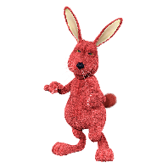
Organizers
What is the main thought of each of the following sections?
- Reading Response to The Rabbits, 1–3 double panels:
Where (setting)
Who (character)
What
Emotions (tone)
Main Thought

- Reading Response to The Rabbits, 4–7 double panels:
Where (setting)
Who (character)
What
Emotions (tone)
Main Thought

- Reading Response to The Rabbits, 8–11 double panels:
Where (setting)
Who (character)
What
Emotions (tone)
Main Thought

- Reading Response to The Rabbits, 12–15 double panels:
Where (setting)
Who (character)
What
Emotions (tone)
Main Thought

- Reading Response to The Rabbits, 16–19 double panels:
Where (setting)
Who (character)
What
Emotions (tone)
Main Thought

Reflect on the Graphic Novel

At the end of the novel, Shaun Tan and John Marsden make some comments on the story of The Rabbits. As you read these comments, you gain more information and insight as to what the thinking was behind the story.
As you reflect on the graphic novel, you might find yourself asking more questions:

- The rabbits were different! How do we deal with people and things that are different? What is the basis of understanding others who are different?

- What does the statement, “And stole our children” mean?

- What is your perception of the ending statement: “Who will save us from the rabbits”?

- Think about the various panels. What about the wall at the end? What do you think the text creators are communicating?

- What was the attitude towards the rabbits? Was it reciprocated?

- What is the central theme of the novel?

