Poems for Poetry Analysis

Remember, you only need to annotate 6 of the 9 poems provided.

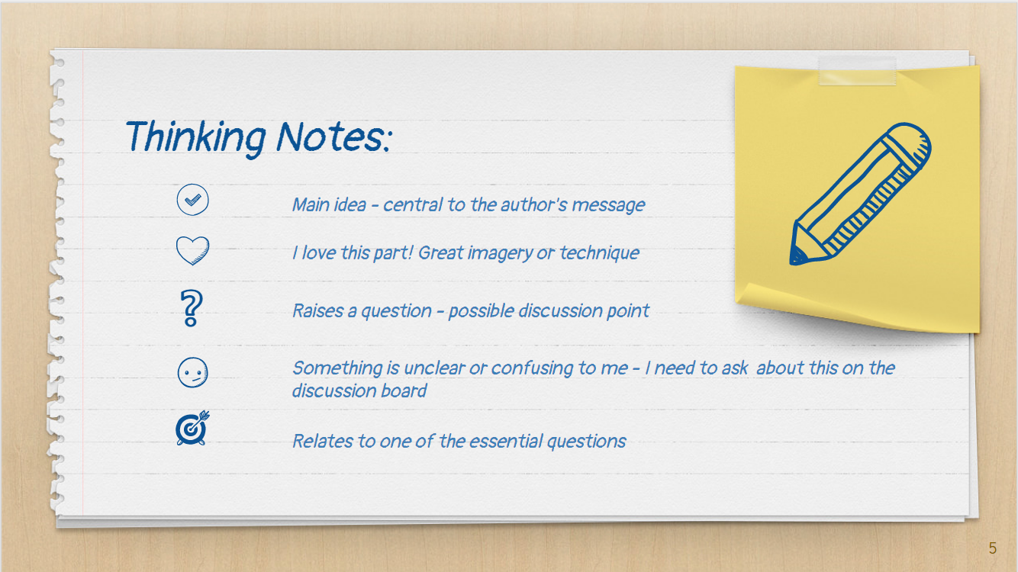 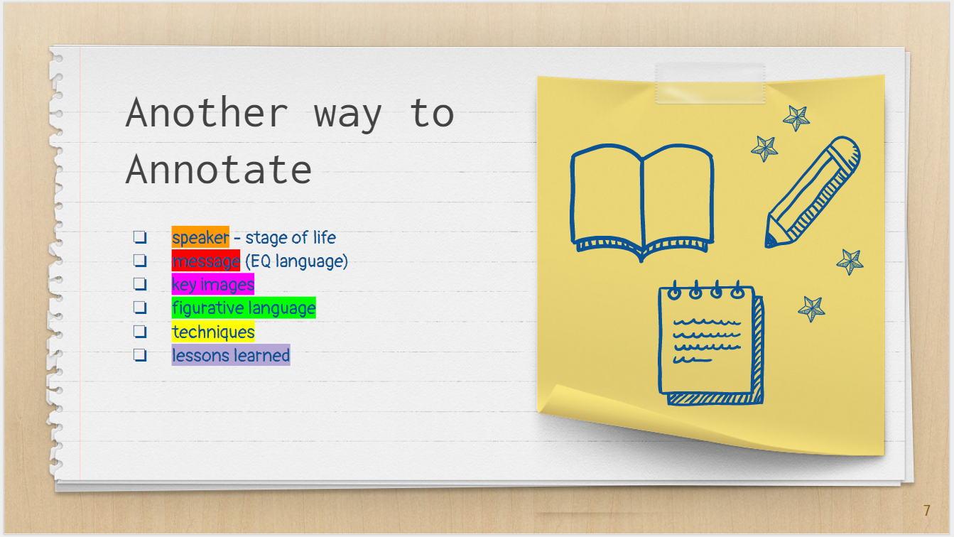

|  |
| --- |
| If you want to use the thinking notes icons, simply click the icon and CTRL+C to copy and then CTRL+V to paste; you will have to move them and re-size them to fit the area of the poem. |

    

[**Review this exemplar for an approach to annotating poetry.**](https://drive.google.com/file/d/1KsKB54YzgfxYH5TNjlKoZq_citVyrtLE/view?usp=sharing)

Acquainted with the Night by Robert Frost 3

Calgary 2 a.m. by Christopher Wiseman 4

Circular Saws by Fred Cogswell 5

First Practice by Gary Gildner 6

In School Days by John Greenleaf Whittier 7

On the Value of Fantasies by Elizabeth Brewster 9

The Layers by Stanley Kunitz 10

To Be of Use by Marge Piercy 11

Young Soul by Amiri Baraka (LeRoi James) 12

Works Cited13

# Acquainted with the Night by Robert Frost

I have been one acquainted with the night.

I have walked out in the rain--and back in the rain.

I have outwalked the furthest city light.

I have looked down the saddest city lane.

I have passed by the watchman on his beat

And dropped my eyes, unwilling to explain.

I have stood still and stopped the sound of feet

When far away an interrupted cry

Came over houses from another street,

But not to call me back or say good-by;

And further still at an unearthly height,

One luminary clock against the sky

Proclaimed the time was neither wrong nor right.

I have been one acquainted with the night.

# 

# 

# Calgary 2 a.m. by Christopher Wiseman

In spite of the fact that it’s twenty below

and winter has gone on for five long months,

in spite of being starved, starved almost to death

for greenness and warmth, flowers and birds,

in spite of the deadness of endless classrooms,

shopping centres, television shows,

in spite of the pains in the gut, the migraines,

the wakings, the palpitations,

in spite of a guilty knowledge of laziness,

of failure to meet some obligations,

in spite of all these things, and more,

I have to report that the moon tonight

is filling the house with a wild blueness,

my children grow, excel, are healthy,

my wife is gentle, there are friends,

and once in a while a poem will come.

in spite of the fact that it's twenty below,

tonight I smile. Summer bursts inside me.

# Circular Saws by Fred Cogswell

When the circular saw

chewed up my fingernail

I said to myself

“This is a bad dream

and I shall wake up”

but I didn't

and in a few minutes

the pain began

after that, I had

a scar to remind me

not to go

near circular saws

but I soon found

they had ways

of disguising themselves

so that watch as I might

they were always

hurting me

now inside and out

I am covered with scars

but that is not

the worst I've learned

the worst thing is

that under the masks

I wear and without

intending to be

I am a circular saw

# First Practice by Gary Gildner

After the doctor checked to see

we weren't ruptured,

the man with the short cigar took us

under the grade school,

where we went in case of attack

or storm, and said

he was Clifford Hill, he was

a man who believed dogs

ate dogs, he had once killed

for his country, and if

there were any girls present

for them to leave now.

No one

left. OK, he said, he said I take

that to mean you are hungry

men who hate to lose as much

as I do. OK. Then

he made 2 lines of us

facing each other,

and across the way, he said,

is the man you hate most

in the world,

and if we are to win

that title I want to see how.

But I don't want to see

any marks when you're dressed,

he said. He said, *Now*.

# In School-days by John Greenleaf Whittier

Still sits the school-house by the road,

A ragged beggar sleeping;

Around it still the sumachs grow,

And blackberry-vines are creeping.

Within, the master’s desk is seen,

Deep scarred by raps official;

The warping floor, the battered seats,

The jack-knife’s carved initial;

The charcoal frescoes on its wall;

Its door’s worn sill, betraying

The feet that, creeping slow to school,

Went storming out to playing!

Long years ago a winter sun

Shone over it at setting;

Lit up its western window-panes,

And low eaves’ icy fretting.

It touched the tangled golden curls,

And brown eyes full of grieving,

Of one who still her steps delayed

When all the school were leaving.

For near her stood the little boy

Her childish favor singled:

His cap pulled low upon a face

Where pride and shame were mingled.

Pushing with restless feet the snow

To right and left, he lingered;—

As restlessly her tiny hands

The blue-checked apron fingered.

He saw her lift her eyes; he felt

The soft hand’s light caressing,

And heard the tremble of her voice,

As if a fault confessing.

“I'm sorry that I spelt the word:

I hate to go above you,

Because,” —the brown eyes lower fell,—

“Because, you see, I love you!”

Still memory to a gray-haired man

That sweet child-face is showing.

Dear girl! the grasses on her grave

Have forty years been growing!

He lives to learn, in life's hard school,

How few who pass above him

Lament their triumph and his loss,

Like her, because they love him.

# On the Value of Fantasies by Elizabeth Brewster

The teacher on the morning radio program

disapproves because her girl students

have such unrealistic fantasies.

They all think they will go to college,

marry a lawyer or a professor,

have two kids and two cars,

and live happily ever after.

And she gets them to play a game

in which Linda becomes a widow at fifty,

Paulette is deserted at thirty-five

and has to bring up four kids

on a steno’s salary[1], and poor Jennifer

never marries at all.

How will they cope?

Of course it’s a matter of

one fantasy against another;

and sometimes it’s fun

to imagine oneself bearing up against adversity.

Myself, though, I agree with the kids

that it’s rather a dumb game.

It’s true, life is full of these dirty tricks,

but being prepared for the worst may make it happen.

(More might be said

for fantasizing about space travel

or maybe about being a mermaid.)

I still hope (two months before my fifty-third birthday)

that I may yet meet that handsome stranger

all the fortunetellers have told me about;

that sometime my lottery ticket

will win a tax-free fortune,

and that my poems become household words

and make the next edition of Colombo’s *Quotations[2]*.

I might as well believe in heaven, too,

for all the good it will do me to admit

statistics are against it.

# The Layers by Stanley Kunitz

I have walked through many lives,

some of them my own,

and I am not who I was,

though some principle of being

abides, from which I struggle

not to stray.

When I look behind,

as I am compelled to look

before I can gather strength

to proceed on my journey,

I see the milestones dwindling

toward the horizon

and the slow fires trailing

from the abandoned camp-sites,

over which scavenger angels

wheel on heavy wings.

Oh, I have made myself a tribe

out of my true affections,

and my tribe is scattered!

How shall the heart be reconciled

to its feast of losses?

In a rising wind

the manic dust of my friends,

those who fell along the way,

bitterly stings my face.

Yet I turn, I turn,

exulting somewhat,

with my will intact to go

wherever I need to go,

and every stone on the road

precious to me.

In my darkest night,

when the moon was covered

and I roamed through wreckage,

a nimbus-clouded voice

directed me:

“Live in the layers,

not in the litter.”

Though I lack the art

to decipher it,

no doubt the next chapter

in my book of transformations

is already written.

I am not done with my changes.

# To Be of Use by Marge Piercy

The people I love the best

jump into work head first

without dallying in the shallows

and swim off with sure strokes almost out of sight.

They seem to become natives of that element,

the black sleek heads of seals

bouncing like half-submerged balls.

I love people who harness themselves, an ox to a heavy cart,

who pull like water buffalo, with massive patience,

who strain in the mud and the muck to move things forward,

who do what has to be done, again and again.

I want to be with people who submerge

in the task, who go into the fields to harvest

and work in a row and pass the bags along,

who are not parlor generals[3] and field deserters[4]

but move in a common rhythm

when the food must come in or the fire be put out.

The work of the world is common as mud.

Botched, it smears the hands, crumbles to dust.

But the thing worth doing well done

has a shape that satisfies, clean and evident.

Greek amphoras[5] for wine or oil,

Hopi[6] vases that held corn, are put in museums

but you know they were made to be used.

The pitcher cries for water to carry

and a person for work that is real.

# Young Soul by Amiri Baraka (LeRoi James)

First, feel, then feel, then

read, or read, then feel, then

fall, or stand, where you

already are. Think

of your self, and the other

selves... think

of your parents, your mothers

and sisters, your bentslick

father, then feel, or

fall, on your knees

if nothing else will move you,

then read

and look deeply

into all matters

come close to you

city boys —

country men

Make some muscle

in your head, but

use the muscle

in yr heart

# Works Cited

Baraka, Amiri. “Young Soul”. *Imprints 12*. Ed. Kathy Evans, Lori

Farren, Janet Hannaford, Stuart Poyntz, Jim Robson, and Dom Saliani. Toronto. Gage Learning, 2002. 189. Print.

Brewster, Elizabeth. “On the Value of Fantasies.” *Imprints 12*. Ed. Kathy Evans, Lori

Farren, Janet Hannaford, Stuart Poyntz, Jim Robson, and Dom Saliani. Toronto. Gage Learning, 2002. 184. Print.

Cogswell, Fred. “Circular Saws.” *Imprints 12*. Ed. Kathy Evans, Lori

Farren, Janet Hannaford, Stuart Poyntz, Jim Robson, and Dom Saliani. Toronto. Gage Learning, 2002. 249. Print.

Frost, Robert. “Acquainted with the Night.” *Imprints 12*. Ed. Kathy Evans, Lori

Farren, Janet Hannaford, Stuart Poyntz, Jim Robson, and Dom Saliani. Toronto. Gage Learning, 2002. 212. Print.

Gildner, Gary “First Practice” *One Poet’s Notes*.

<http://edwardbyrne.blogspot.ca/search?q=first+practice> (3 June, 2014)

Kunitz, Stanley. “The Layers.” *Imprints 12*. Ed. Kathy Evans, Lori

Farren, Janet Hannaford, Stuart Poyntz, Jim Robson, and Dom Saliani. Toronto. Gage Learning, 2002. 189. Print.

Piercy, Marge. “To Be of Use.” *Imprints 12*. Ed. Kathy Evans, Lori

Farren, Janet Hannaford, Stuart Poyntz, Jim Robson, and Dom Saliani. Toronto. Gage Learning, 2002. 223. Print.

Whittier, John Greenleaf “In School-days.” *Poetry Foundation*

<https://www.poetryfoundation.org/poems/45487/in-school-days>

(3 June, 2014)

Wiseman, Christopher “Calgary 2 a.m.” The Writer’s Almanac. Garrison Keillor.   
 <https://writersalmanac.publicradio.org/index.php%3Fdate=2006%252F03%252F18.html>   
 (3 June, 2014)

1. **steno’s salary**: stenographer’s; a stenographer transcribes speech using shorthand writing
2. **Colombo’s *Quotations***: a reference work containing quotations by notable Canadians, edited by John Robert Colombo.
3. **parlor generals**: generals who avoid the battlefield
4. **field deserters**: soldiers who flee during battle
5. **amphoras**: two-handled jars
6. **Hopi**: Aboriginal people of northeast Arizona