**3.5 Punctuation and Sentence Errors**

Edit Mohammed’s passage for

* Punctuation
* Fragments, run-ons
* Comma splices
* Word choice in relation to tone and mood. Can Mohammed use different (better or more specific) words to create his tone and mood?
* Verb tense

THE CAR SAT IN THE FARTHEST CORNER OF THE

DRIVEWAY. It was an old junker up on blocks that Timmy’s father keeps saying he’s going to repair but never does timmy is glad it’s still around because Timmy likes to sit in there and think and to be alone.

Timmy walks up the driveway, his feet crunching



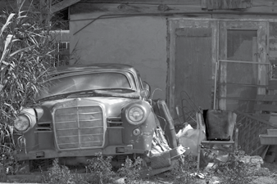

©Thinkstock

the leaves which have blown up against the blocks. He looks once to his left. Once to his right. Once straight ahead into the neighbour’s kitchen window no one watching. He lifts up the handle, then doubles over like a lawnchair. He enters head first and closes the door behind him. He arranges himself so that his legs are stretched out, his back resting against the passenger door.

The inside of the car is musty, it’s not an unpleasant smell in fact it’s become one of Timmy’s favourite it brings with it a sense of comfort, a sense of belonging.

The seats are made of cracked leather, and in the backseat there are spots where the springs have broken and stuffing is poking out. In the winter. A certain family of mice always makes their way to that hole to wait out the winter months.

The front seat of the car is where Timmy spends most of his time. This can be seen by the countless number of Bazooka Joe gum wrappers and little discarded comics on the floor. The glove compartment is stocked with various forms of junk food, which go against Timmy’s eating habits, but while he’s in here, he’s himself – no limitations.

Timmy opens the glove box and opens up a piece of Bazooka Joe, he sits back and thinks about the past couple of days: what he saw, what he’s learned. When his gum gets stale. He picks it out of his mouth and sticks it to a pile of already-been-chewed hum that’s on the floor: a tall, pink mass with thousands of teeth marks imprinted on it.