Unit 4 Name:

Date:

4-2: Reading Instructions

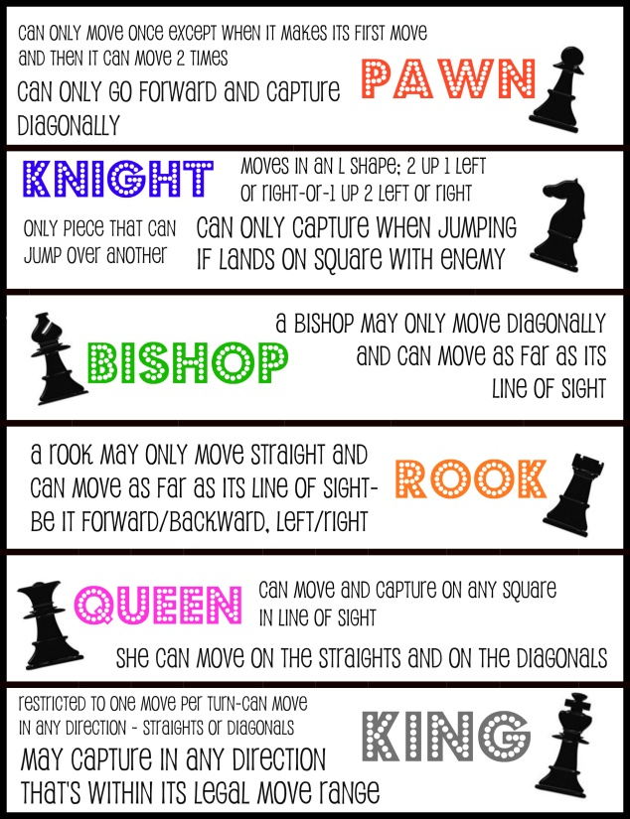 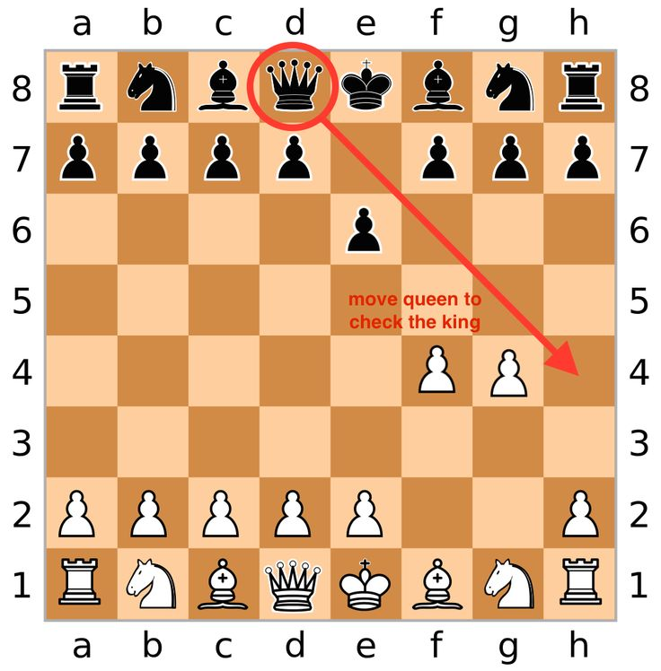

1. Explain the role of one of the game pieces of chess. Do not copy the words above. ( /2 marks)

|  |
| --- |
|  |

1. Why do the game pieces have different shapes and icons? ( /1 mark)

|  |
| --- |
|  |

1. How does the second infograph show information? Explain what information it shows. ( /2 marks)

|  |
| --- |
|  |

**Total of Section 1: / 5 marks**

Section 2: Wacky Game Instructions

1. Identify the name of game. ( /1 mark)

|  |
| --- |
|  |

1. Identify the number and age of players. ( /1 mark)

|  |
| --- |
|  |

1. Who would enjoy this game? ( /1 mark)

|  |
| --- |
|  |

1. Identify and describe the equipment needed for the game. (see rubric below)

|  |
| --- |
|  |

1. Identify the object of the game.

|  |
| --- |
|  |

1. Number the instructions in sequential order. Ensure they make sense and are clear to the reader. Include **all** necessary instructions.

|  |
| --- |
|  |

1. Include an infograph of your game that adds more information for the reader such as how to play the game or game statistics. You can choose what you want to include in the picture. Some ideas are:

* Equipment used in the game
* Logo to represent the game
* Graphs, charts, maps, legends, or icons
* Board or field design
* Flow chat or graphic organizer
* The cover of the game box (if you are using a game that

already exists, DO NOT copy the cover of the original game box. Make your own cover for your version of the game.)

* How the game looks when it is set up
* A scene of people playing the game

Ensure the font you use is readable.

Infograph

|  |
| --- |
|  |

|  |
| --- |
| Game Instructions and Picture Rubric |

|  |  |  |  |  |  |
| --- | --- | --- | --- | --- | --- |
| Criteria | Excellent  5 | | Proficient  4 | Satisfactory  3 | Limited  2 |
| **Content /5** | * I developed *insightful* ideas and images to describe the equipment, explain the object of the game, and how to play it. * I used *precise* details. | | * I used *thoughtful* ideas and images to describe the equipment, explain the object of the game, and how to play it. * I used *logical* details. | * I developed *appropriate* ideas and images to describe the equipment, explain the object of the game, and how to play it. * I used *general* details. | * I *underdeveloped superficial* ideas and images to describe the equipment, explain the object of the game, and how to play it. * I used *vague* details. |
| **Organization /5** | * I organized my information *skillfully* using sequential order. * I used *effective* transitions. | | * I organized my information *logically* using sequential order*.* * I used *reasonable* transitions. | * I organized my information *clearly* using sequential order*.* * I used *clear* transitions. | * I organized my information *unclearly* using sequential order. * I used *ineffective* transitions. |
| **Words and Sentences**  **/5** | * I chose *precise* words, and *well* varied sentences to *convincingly* explain the wacky game. | | * I chose *reasonable* adjectives, words that appeal to the senses, and *mostly* variedsentences to *logically* explain the wacky game. | * I chose *clear* adjectives, words that appeal to the senses, and *somewhat* variedsentences to *generally* explain the wacky game. | * I chose *vague* adjectives, words that appeal to the senses, and *unvaried* sentences to *ineffectively* explain the wacky game. |
| **Conventions /5** | * I communicated *effectively* with *no* errors. | | * I communicated *thoughtfully* with *few* errors. | * I communicated *clearly* with *some* errors. | * I communicated *ineffectively* with *many* errors. |
| **Insufficient** | Your attempt to respond is *insufficient*. **Contact your teacher** to discuss suggestions for improvement. | | | | |
| **Total: /20** | | | | | |
| **Assessment** | | **Areas of Strength:** | | | |
| **Target for Improvement:** | | | |

**Total of Section 2: / 23 marks**

**Overall Total: / 28 marks**



**Save Your File**

Name your file in this format: jsmithla5_4-2-game and save your file to your Notebook Folder