Unit 5 Name:

Date:

5-1: Identifying Story Elements in “Sneak Thief Sneakers”

Identify the story elements of “The Sneak Thief’s Sneakers”.

Before Reading

1. Look at the title and the pictures on pp. 78-81. Predict what you think this story will be about. ( /1 mark)

|  |
| --- |
|  |

During Reading

1. Describe the main character and identify what he or she wants. ( /2 marks)

|  |
| --- |
|  |

1. What is the setting of the story? ( /2 marks)

|  |
| --- |
|  |

1. Write down physical features and personality traits of the three suspects. ( /6 marks)

|  |
| --- |
|  |

1. What is the problem or conflict in the story? ( /2 marks)

|  |
| --- |
|  |

1. From what point of view is the story told? ( /1 mark)

|  |
| --- |
|  |

1. What are two distractions or red herrings for the person trying to solve the mystery? ( /2 marks)

|  |
| --- |
|  |

1. What is the order in which the clues appear? ( /3 marks)

|  |
| --- |
|  |

1. Identify one simile and one metaphor in the story. What is the meaning of each in everyday language? ( /4 marks)

|  |  |  |
| --- | --- | --- |
| **Example** | **Type of Figure of Speech (Simile, Metaphor)** | **Meaning in Every Day Language** |
|  |  |  |
|  |  |  |

**Total of Section 1: /23 marks**

Section 2: Identifying Story Elements in “The Game Master’s Challenge: A Radio Play”

Before Reading

1. Based on the title and the pictures on pp. 82-87 of *Literacy in Action 5B*, predict what this play will be about. ( /1 mark)

|  |
| --- |
|  |

During Reading

1. Authors choose their words carefully when they describe the characters in a story. The words the characters say and the actions they do can be important clues for the observant reader.

Choose either Dennis or Randy and complete the chart below. ( /6 marks)

|  |  |  |  |
| --- | --- | --- | --- |
| **Describe the Character’s Appearance on p. 83** | **Character’s Words (Choose two significant quotations that reveal the character’s personality)** | **Character’s Actions (Choose two significant actions that reveal the character’s personality)** | **How Other Characters (such as the Game Master) Respond to the Character** |
|  |  |  |  |

1. What were the clues in the story? ( /6 marks)

|  |
| --- |
|  |

1. Identify one example of foreshadowing in the story. ( /1 mark)

|  |
| --- |
|  |

1. How did Dennis’ and Randy’s personalities influence how the story ended? ( /2 marks)

|  |
| --- |
|  |

1. Did the characters’ personalities help you connect more to the story? Why or why not? ( /2 marks)

|  |
| --- |
|  |

**Total of Section 2: /18 marks**

Section 3: Story Planning - SWBS Chart

Look at the picture below. Use your imagination to plan a story the picture has helped you think about. In the SWBS Chart below, you will create a basic story outline. The SWBS chart will help you plan story elements.

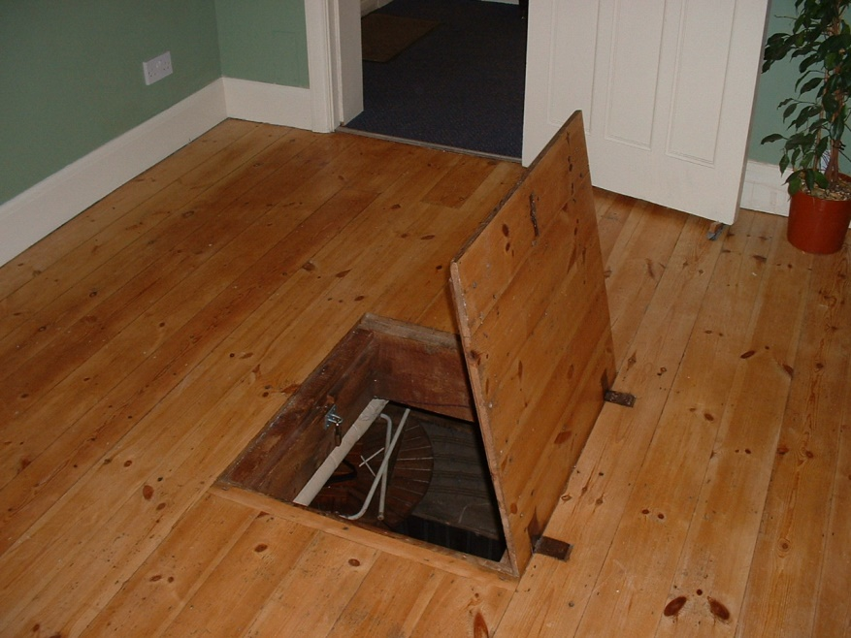

**SWBS CHART**

|  |  |  |  |
| --- | --- | --- | --- |
| Somebody  Identify a character who will face a problem or a conflict. | Wanted  Motivation: What does the character want/need  OR what is the  character's goal? | But  Problem: What is the conflict or  problem that the  character faces? | So  Solution: What is the solution to  the problem or how does  the character reach the  goal? |
| Example from *Ali Baba and the Forty Thieves*  A poor woodcutter | Wants treasure to become rich | Character vs. Character  Poor man faces a dangerous situation with 40 thieves. | Learns the magic words, “Open Sesame.”  Waits until the thieves leave. Makes a plan and with the help of his friend, a young girl, outwits the thieves, and inherits the treasure. |
| Your story plan for the picture above: |  |  |  |

**Total of Section 3: /5 marks**

Overall Total: /46 marks



**Save Your File**

Name your file in this format: jsmithla5_5-1-sneakers and save your file to your Notebook Folder