Unit 5 Name:
Date:

5-1: Identifying Story Elements in “Sneak Thief Sneakers”

Identify the story elements of “The Sneak Thief’s Sneakers”.

Before Reading

- Look at the title and the pictures on pp. 78-81. Predict what you think this story will be about. ( /1 mark)

During Reading

- Describe the main character and identify what he or she wants. ( /2 marks)

- What is the setting of the story? ( /2 marks)

- Write down physical features and personality traits of the three suspects. ( /6 marks)

- What is the problem or conflict in the story? ( /2 marks)

- From what point of view is the story told? ( /1 mark)

- What are two distractions or red herrings for the person trying to solve the mystery? ( /2 marks)

- What is the order in which the clues appear? ( /3 marks)

- Identify one simile and one metaphor in the story. What is the meaning of each in everyday language? ( /4 marks)

Example | Type of Figure of Speech (Simile, Metaphor) | Meaning in Every Day Language

Total of Section 1: /23 marks

Section 2: Identifying Story Elements in “The Game Master’s Challenge: A Radio Play”

Before Reading

- Based on the title and the pictures on pp. 82-87 of Literacy in Action 5B, predict what this play will be about. ( /1 mark)

During Reading

- Authors choose their words carefully when they describe the characters in a story. The words the characters say and the actions they do can be important clues for the observant reader.

Choose either Dennis or Randy and complete the chart below. ( /6 marks)

Describe the Character’s Appearance on p. 83 | Character’s Words (Choose two significant quotations that reveal the character’s personality) | Character’s Actions (Choose two significant actions that reveal the character’s personality) | How Other Characters (such as the Game Master) Respond to the Character

- What were the clues in the story? ( /6 marks)

- Identify one example of foreshadowing in the story. ( /1 mark)

- How did Dennis’ and Randy’s personalities influence how the story ended? ( /2 marks)

- Did the characters’ personalities help you connect more to the story? Why or why not? ( /2 marks)

Total of Section 2: /18 marks

Section 3: Story Planning - SWBS Chart

Look at the picture below. Use your imagination to plan a story the picture has helped you think about. In the SWBS Chart below, you will create a basic story outline. The SWBS chart will help you plan story elements.

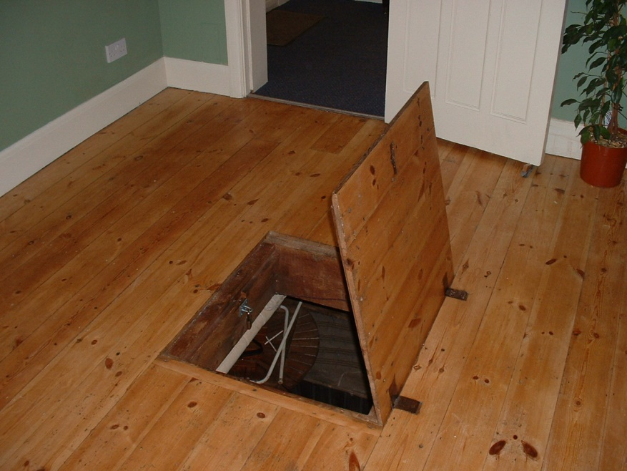

SWBS CHART
Somebody  Identify a character who will face a problem or a conflict. | Wanted  Motivation: What does the character want/need  OR what is the  character's goal? | But  Problem: What is the conflict or  problem that the  character faces? | So  Solution: What is the solution to  the problem or how does  the character reach the  goal?
Example from Ali Baba and the Forty Thieves  A poor woodcutter | Wants treasure to become rich | Character vs. Character  Poor man faces a dangerous situation with 40 thieves. | Learns the magic words, “Open Sesame.”  Waits until the thieves leave. Makes a plan and with the help of his friend, a young girl, outwits the thieves, and inherits the treasure.
Your story plan for the picture above:

Total of Section 3: /5 marks

Overall Total: /46 marks


Save Your File
Name your file in this format: jsmithla5_5-1-sneakers and save your file to your Notebook Folder

