Unit 5 Name:

Date:

5-2: “A Mysteriously Good Writer”

1. According to the reading “A Mysteriously Good Writer” on pp. 98-100 of *Literacy in Action 5B*, what are Eric Wilson’s two goals? ( /2 marks)

|  |
| --- |
|  |

1. Identify four ways he reaches his goals and writes realistic stories? Use details from the story in your response. ( /4 marks)

|  |
| --- |
|  |

1. How does Eric Wilson write stories that appeal to kids? Use two details from the story in your response. ( /2 marks)

|  |
| --- |
|  |

**Total of Section 1: / 8 marks**

Section 2: Write a Story Beginning

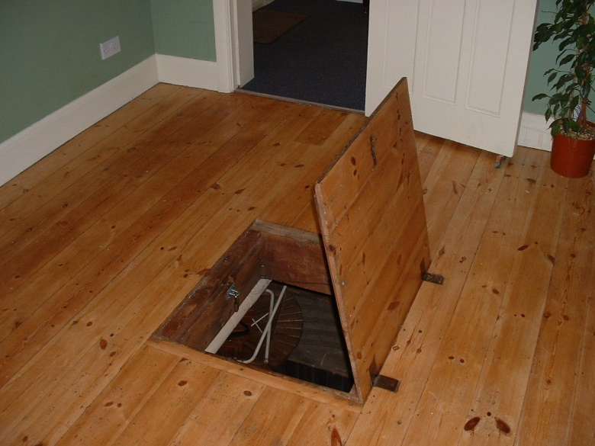

Write a story beginning for the picture above that hooks the reader. You may begin in the middle of the action, by describing the setting, the character, or begin with the problem or dialogue. The introduction should be short and get right to the point.

* Use five effective active verbs.
* Refer to your story plan or SWBS Chart from Assignment 5-1.

|  |
| --- |
| Story Beginning Rubric |

|  |  |  |  |  |  |
| --- | --- | --- | --- | --- | --- |
| Criteria | Excellent  5 | | Proficient  4 | Satisfactory  3 | Limited  2 |
| **Content**  **/5** | * I used *insightful* ideas to hook the reader. * I used *precise* details. | | * I used *thoughtful* ideas to hook the reader. * I used *logical* details. | * I developed *appropriate* ideas to hook the reader. * I used *general* details. | * I *underdeveloped superficial* ideas to hook the reader. * I used *vague* details. |
| **Techniques**  **/5** | * I developed my writing *convincingly* using *active verbs,* and an *effective* story beginning*.* | | * I developed my poetic writing *reasonably* using *active verbs,* and a *logical* story beginning*.* | * I developed my poetic writing *clearly* using *active verbs,* and a *general* story beginning*.* | * I organized my writing *vaguely* using *active verbs,* and a *vague* story beginning*.* |
| **Presentation /5** | * I communicated *effectively* using *precise* concrete words with *no* errors. | | * I communicated *thoughtfully* using *reasonable* concrete words with *few* errors. | * I communicated *clearly* using *appropriate* words with *some* errors. | * I communicated *ineffectively* using *vague* non-concrete words with *many* errors. |
| **Insufficient** | Your attempt to respond is *insufficient*. **Contact your teacher** to discuss suggestions for improvement. | | | | |
| **Total: /15** | | | | | |
| **Assessment** | | **Areas of Strength:** | | | |
| **Target for Improvement:** | | | |

Story Beginning

|  |
| --- |
|  |

**Total of Section 2: / 15 marks**

**Overall Total: / 23 marks**



**Save Your File**

Name your file in this format: jsmithla5_5-2-beginning and save your file to your Notebook Folder