Unit 5 Name:

Date:

5-7: Novel Study Final Assignment

1. While reading the novel, what connections did you make to your life, to something you read or saw before? Provide two examples for each column in the chart below. The bulleted points are suggestions to guide your thinking.

|  |  |
| --- | --- |
| **Personal** | **Text** |
| * Reminder of an experience you had or person you know ( /2 marks) | * Reminder of something you read or saw on TV or in a movie ( / 2 marks) |
|  |  |

1. What did the author show about friendship in the novel? Explain your response and provide an example from the story. (/2 marks)

|  |
| --- |
|  |

**Total of Section 1: /6 marks**

Section 2: Reader’s Choice

Choose **one** of the following options

|  |
| --- |
| **Option A**   * Write a **book review or newsletter** that examinessignificant eventsin the novel. Be sure to include a headline!   Include the following items.   1. The event that hooks the reader’s curiosity at the beginning of the novel.    * Some suspenseful events.    * A description of the problems the character must overcome.    * Explain the solution to the problem. 2. Describe the book’s effect on the reader. Provide three reasons for your thoughts. Explain using examples and quotations from the novel. |

|  |
| --- |
| **Option B**  Design a **game** (board game, cards, or video game) based on key events in the novel.   * Show the main events of the plot. * Include rules. * Depending on the type of game:   + Develop a board or storyboard that considers either the sequence of main events, character, and/or setting.   + Develop game pieces to represent either the characters and/or significant events. * Consider the games *Life, Monopoly, Clue, Settlers of Catan, Ticket to Ride,* and/or *Memory* as templates for building a game related to your novel. * Submit the game or digital photos, and rules to the Submission folder. |

|  |
| --- |
| **Option C**  Choose key events from one scene and construct a six scene **storyboard** from the novel.  Include the following items.   * The beginning event.   + Some suspenseful events.   + The problem the character must overcome.   + The solution to the problem.   2.Write a paragraph describing the book’s effect on the reader. Provide three reasons for your thoughts. Explain using examples and quotations from the novel.  **You may construct the storyboard by hand, using textboxes below and adding images or by using the ReadWriteThink Comic Creator**  [http://www.readwritethink.org/classroom-resources/student-interactives/comic-creator-30021.html](http://www.readwritethink.org/classroom-resources/student-interactives/comic-creator-30021.html%20)   1. Enter the title of your story and a subtitle. Add your name as the author. Click the arrow when done. 2. Add people and animals by clicking on the stick person. Use the left and right arrows to change figures. 3. Change backgrounds using the up and down arrows on the upper right side. Be sure to add a background or your characters will show up with a blank background. 4. Don’t write anything in the caption boxes because they don’t print out properly. 5. Add a speech or thought bubble by clicking on the speech bubble. Use the left and right arrows to change bubbles. 6. Add props by clicking on the TV. Use the left and right arrows to change props. 7. Either take a photo of your cartoon, capture an image of it, print out your cartoon, scan it, save it on your desktop, and put it in the correct submission folder for your teacher. |

**Submit the game/newsletter/book review/storyboard to your teacher along with this worksheet.**

|  |
| --- |
| 5-7 Final Novel Assignment Rubric |

|  |  |  |  |  |  |
| --- | --- | --- | --- | --- | --- |
| Criteria | Excellent  5 | | Proficient  4 | Satisfactory  3 | Limited  2 |
| **Content /5** | * I used *insightful* events and ideas. * I developed *perceptive* reasons, rules, or visuals. * I included *precise* details. | | * I used *thoughtful* events and ideas. * developed *logical***,** reasons, rules, or visuals. * I included *specific* details. | * I chose *appropriate* events and ideas. * developed *adequate* reasons, rules, or visuals. * I included *some* details. | * I chose *unsuitable* events and ideas. * developed *vague* reasons, rules, or visuals. * I included *imprecise* details or details were lacking*.* |
| **Organization /5** | * I used an *effective* beginning, middle, and end. | | * I used a *logical* beginning, middle, and end. | * I used a *clear* beginning, middle, and end. | * I used an *ineffective* beginning, middle, and end. |
| **Presentation /5** | * I communicated *engagingly* with *no* errors. | | * I communicated *thoughtfully* with *few* errors. | * I communicated *clearly* with *some* errors. | * I communicated *unclearly* with *many errors.* |
| **Insufficient** | Your attempt to respond is *insufficient*. **Contact your teacher** to discuss suggestions for improvement. | | | | |
| **Total: /15** | | | | | |
| **Assessment** | | **Areas of Strength:** | | | |
| **Target for Improvement:** | | | |

|  |
| --- |
|  |

**Total of Section 2: /15 marks**

Section 3: Writing a Mystery Story: Know Your Character Back Story

You will write a mystery story in the next assignment. Recall the planning you did in Assignment 5-1 for this photo.

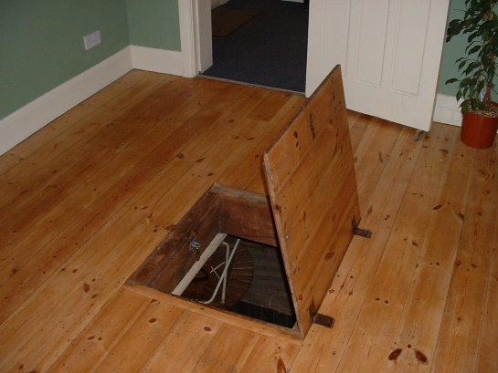

Complete the chart below for your main character. This will help you get to know your character before you write your mystery story so you can make the character seem real and true-to-life for your readers.

**Character Chart**

|  |  |
| --- | --- |
| Character’s Name: |  |
| Character’s Age: |  |

|  |
| --- |
| Basic Facts |
| Look or appearance (give a short description) |  |
| Where he/she lives (e.g., neighbourhood or town) |  |
| Family members (give a few descriptive words for each) |  |
| School or job |  |
| Best friend |  |

|  |
| --- |
| Favourites |
| Game |  |
| Hobby |  |
| Clothing/Outfit |  |
| Role Model |  |
| Music |  |
| Saying |  |

|  |
| --- |
| What Others Notice |
| Something friends like  about him/her |  |
| Something family  members often  complain about |  |
| One statement from  last report card and/or  job review |  |
| Something that often  puzzles friends and/or  family |  |

**Total of Section 3: /5 marks**

**Overall Total: /26 marks**



**Save Your File**

Name your file in this format: jsmithla5_5-7-character and save your file to your Notebook Folder