Unit 5 Name:

Date:

5-8: Essential Questions

1. List five elements every mystery story must have. ( /5 marks)

|  |
| --- |
|  |

1. How can making inferences help you solve mysteries? ( /2 marks)

|  |
| --- |
|  |

1. What techniques do mystery writers use to keep readers interested? ( /2 marks)

|  |
| --- |
|  |

**Total of Section 1: / 9 marks**

Section 2: Writing a Mystery Story

* Recall the story plan you made in Assignment 1.
* Recall the story introduction you wrote in Assignment 2.
* Recall the dialogue you wrote in Assignment 4.

1. Now, you will write the story events to plan your mystery story.

Look at the picture below.

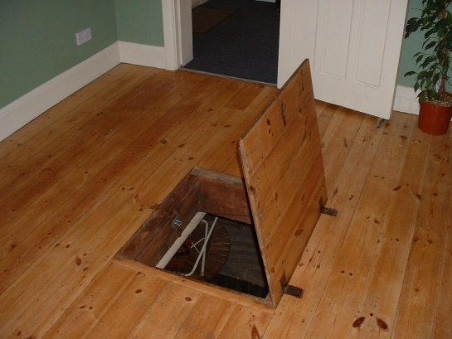

Use your imagination to write a story that the picture has helped you to think about. When writing your story, be sure to

* consider your audience
* focus on your purpose
* organize your thoughts appropriately in sentences and paragraphs
* use vocabulary that is interesting and descriptive
* edit your work directly on your writing. You may use the peer edit checklist in the lesson.

Story Event Plan

Complete your story event plan backward. Begin with the story solution. Write the events that lead to the solution. Use the words *because* and *so* for each step of the story. ( /5 marks)

Write your plan below.

|  |
| --- |
|  |

|  |
| --- |
| Mystery Story Rubric |

|  |  |  |  |  |  |
| --- | --- | --- | --- | --- | --- |
| Criteria | Excellent  5 | | Proficient  4 | Satisfactory  3 | Limited  2 |
| **Content - Elements of Fiction /5** | * I developed *insightful* ideas. * I provided *compelling* character motivation and conflict. * I used *precise* details to describe setting, character, and events. | | * I developed *thoughtful* ideas. * I provided *logical* character motivation and conflict. * I used *reasonable* details to describe setting, character, and events. | * I developed *adequate* ideas. * I provided *appropriate* character motivation and conflict. * I used *general* details to describe setting, character, and events. | * I developed *vague* ideas. * I provided *underdeveloped* character motivation and conflict. * I used *imprecise* details to describe setting, character, and events. |
| **Organization**  **/5** | * I used *effective* order. * I had an *engaging* beginning, *convincing* middle, and *believable* ending. | | * I used *logical* order. * I had an *interesting* beginning, *thoughtful* middle, and *effective* ending. | * I used *basic* order. * I had a *functional* beginning, *acceptable* middle, and *general* ending. | * I used *unsteady* or *confusing* order. * I had an *confusing* beginning, *convincing* middle, and *unrealistic* ending. |
| **Voice: Words and Sentences /5** | * I chose *powerful, meaningful* words. * I communicated *engagingly* with *compelling* sentence variety*.* | | * I chose *strong, thoughtful* words. * I communicated *credibly* with *reasonable* sentence variety. | * I chose *appropriate*, *general* words. * I communicated *clearly* with *appropriate* sentence variety. | * I chose *vague, imprecise* words. * I communicated *unclearly* with *uninteresting* sentence variety. |
| **Conventions /5** | * I communicated *accurately*. | | * I communicated with *few* errors. | * I communicated with *some* errors. | * I communicated with *many errors.* |
| **Insufficient** | Your attempt to respond is *insufficient*. **Contact your teacher** to discuss suggestions for improvement. | | | | |
| **Total: /20** | | | | | |
| **Assessment** | | **Areas of Strength:** | | | |
| **Target for Improvement:** | | | |

Type your story below.

|  |
| --- |
|  |

**Total of Section 2: / 25 marks**

Section 3: Reflection

Answer the questions below to show your knowledge of this unit.

1. Describe and explain have you learned about writing mystery stories? ( /2 marks)

|  |
| --- |
|  |

**Total of Section 3: / 2 marks**

**Overall Total: / 36 marks**



**Save Your File**

Name your file in this format: jsmithla5_5-8-story and save your file to your Notebook Folder