Unit 6 Name:

Date:

6-1: Identifying Canadian Symbols

1. Tell a story to explain why the loon(ie) is a national symbol of Canada on the cartoon poster below. You must add captions to each panel or picture.
2. Your captions should explain what is going on in each panel as if you were narrating a story.
3. The captions should go together and make a short story about making the loonie. You need a beginning, middle and end.
4. Ensure you use the word **symbol** appropriately in your response.
5. Each caption must be two or three sentences long. You must write complete sentences for your captions. Make sure to read over your captions a few times to make sure you haven't missed any mistakes. You are expected to use correct spelling, grammar, and punctuation.
6. You must also add a title to your storyboard.

|  |
| --- |
| Captions Rubric |

|  |  |  |  |  |  |
| --- | --- | --- | --- | --- | --- |
| Criteria | Excellent  5 | | Proficient  4 | Satisfactory  3 | Limited  2 |
| **Content**  **/5** | * I used *insightful* ideas to show understanding of Canadian symbols. * I used *precise* details. | | * I used *thoughtful* ideas to show understanding of Canadian symbols. * I used *logical* details. | * I developed *appropriate* ideas to show understanding of Canadian symbols. * I used *general* details. | * I *underdeveloped superficial* ideas to show understanding of Canadian symbols. * I used *vague* details. |
| **Presentation /5** | * I communicated *effectively* using *precise* words with *no* errors. | | * I communicated *thoughtfully* using *reasonable* words with *few* errors. | * I communicated *clearly* using *appropriate* with *some* errors. | * I communicated *ineffectively* using *vague* words with *many* errors. |
| **Insufficient** | Your attempt to respond is *insufficient*. **Contact your teacher** to discuss suggestions for improvement. | | | | |
| **Total: /10** | | | | | |
| **Assessment** | | **Areas of Strength:** | | | |
| **Target for Improvement:** | | | |

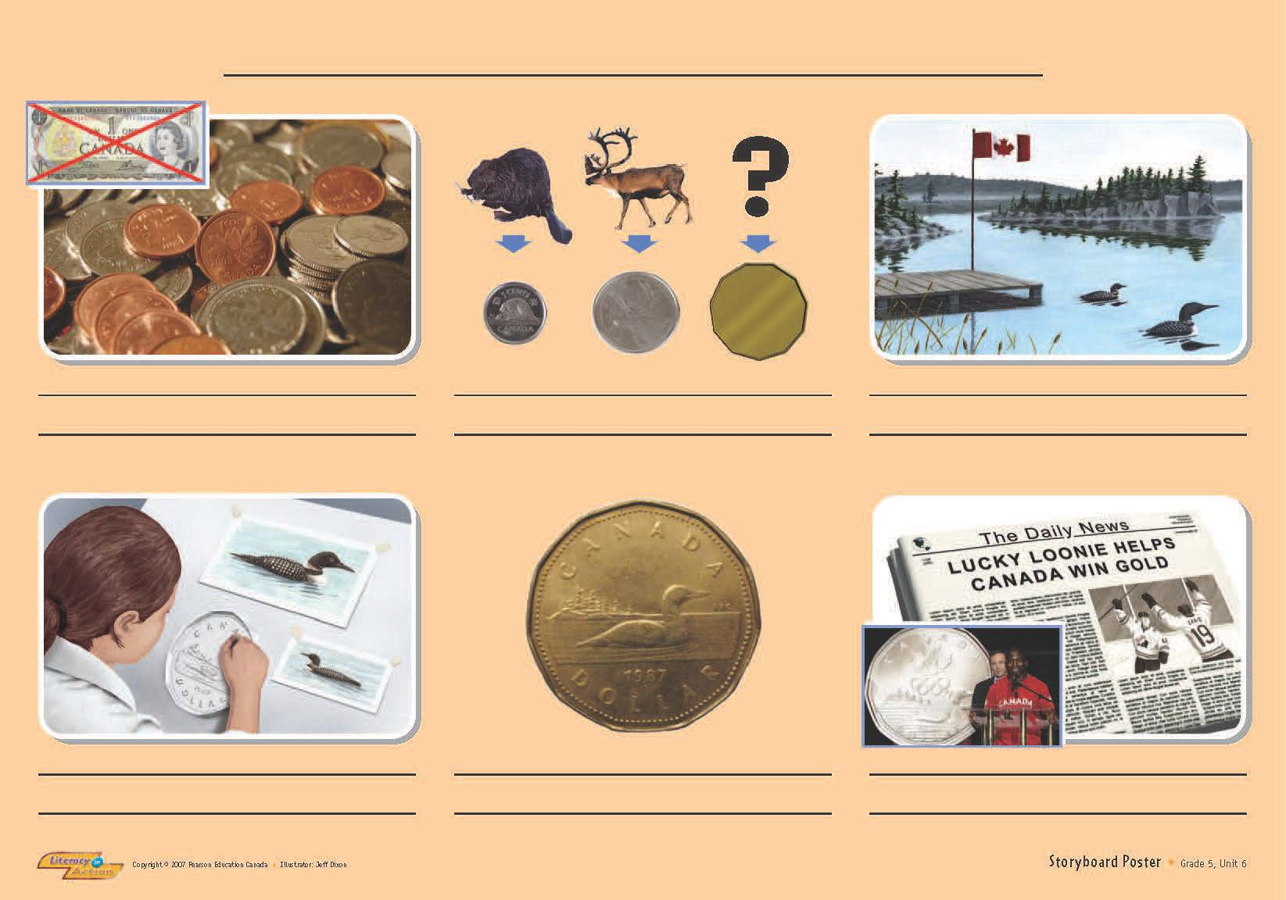

Title:

1. 2. 3.

4. 5. 6.

2. Should the loon be Canada’s national bird? Provide reasons for your response.

|  |
| --- |
| Opinion Rubric |

|  |  |  |  |  |  |
| --- | --- | --- | --- | --- | --- |
| Criteria | Excellent  5 | | Proficient  4 | Satisfactory  3 | Limited  2 |
| **Content**  **/5** | * I used *insightful* reasons to support my opinion. * I used *precise* details. | | * I used *thoughtful* reasons to support my opinion. * I used *logical* details. | * I developed *appropriate* reasons to support my opinion. * I used *general* details. | * I *underdeveloped superficial* reasons to support my opinion. * I used *vague* details. |
| **Presentation /5** | * I communicated *effectively* using *precise* words, *well-varied* sentences with *no* errors. | | * I communicated *thoughtfully* using *reasonable* words, *varied* sentences, with *few* errors. | * I communicated *clearly* using *appropriate* words, *generally* correctsentences with *some* errors. | * I communicated *ineffectively* using *vague* words, *unvaried* sentences with *many* errors. |
| **Insufficient** | Your attempt to respond is *insufficient*. **Contact your teacher** to discuss suggestions for improvement. | | | | |
| **Total: /10** | | | | | |
| **Assessment** | | **Areas of Strength:** | | | |
| **Target for Improvement:** | | | |

|  |
| --- |
|  |

**Overall Total: / 20 marks**



**Save Your File**

Name your file in this format: jsmithla5_6-1-captions and save your file to your Notebook Folder