|  |  |
| --- | --- |
| D:\D drive stuff\online courses\m30-1\08-icons\bakerWD.gif | **Lesson 1.1 Coach’s Corners** |

Complete the ***Coach’s Corner***assessments. Call or e-mail your teacher if you would like additional help.

Name: **<>**

Date: **<>**

Score: **< /8 = % >**







|  |  |  |  |  |
| --- | --- | --- | --- | --- |
|  |  | **<>** |  | **<>** |
| **<>** |  | **<>** | **<>** |  |
|  | **<>** | **<>** |  | **<>** |
| **<>** |  | **<>** | **<>** | **<>** |
| **<>** |  | **<>** | **<>** | **<>** |
| **<>** | **<>** | **<>** | **<>** | **<>** |
|  | **<>** | **<>** |  | **<>** |
| **<>** |  | **<>** | **<>** | **<>** |







**<>**



**<>**



**<>**



**<>**



**<>**





**<>**

  
**<>**



**<>**

|  |  |  |  |
| --- | --- | --- | --- |
|  |  |  |  |
|  |  |  |  |
|  |  |  |  |
|  |  |  |  |
|  |  |  |  |
|  |  |  |  |

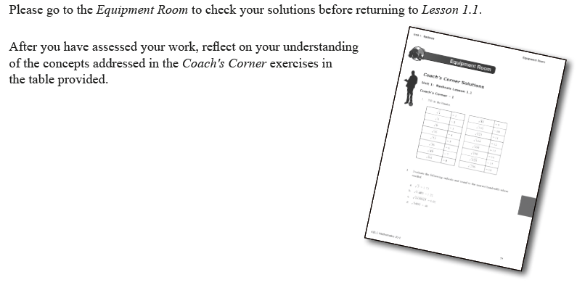







**<>**



**<>**





**<>**



**<>**





**<>**



**<>**



**<>**

Please go to the *Equipment Room* to check your solutions before proceeding to *Game On!*.

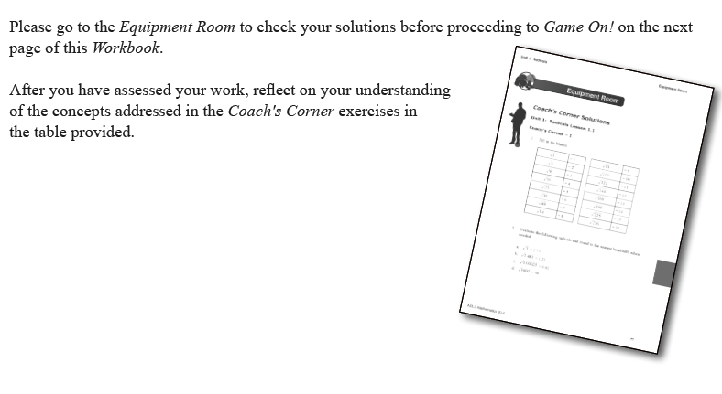After you have assessed your work, reflect on your understanding of the concepts addressed in the *Coach’s Corner* exercises in the table provided.

|  |  |  |  |
| --- | --- | --- | --- |
|  |  |  |  |
|  |  |  |  |
|  |  |  |  |
|  |  |  |  |

