|  |  |
| --- | --- |
| D:\D drive stuff\online courses\m30-1\08-icons\bakerWD.gif | **Lesson 2.3 Coach’s Corners** |

Complete the ***Coach’s Corner!***assessments. Call or e-mail your teacher if you would like additional help.

Name: **<>**

Date: **<>**

Score: **< /8 = % >**





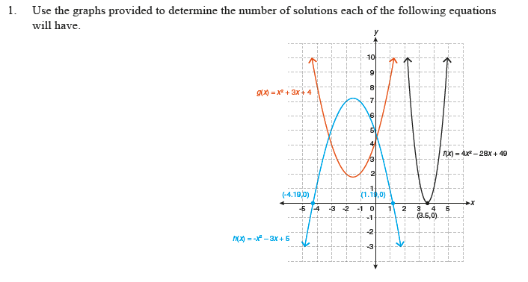



**<>**



**<>**



**<>**



**<>**



**<>**



**<>**



**<>**



**<>**



**<>**



**<>**

Please go to the *Equipment Room* to check your solutions before proceeding to *Game On!*.

After you have assessed your work, reflect on your understanding of the concepts addressed in the *Coach’s Corner* exercises in the table provided.

|  |  |  |  |
| --- | --- | --- | --- |
|  |  |  |  |
|  |  |  |  |
|  |  |  |  |
|  |  |  |  |





**<>**



**<>**



**<>**

Please go to the *Equipment Room* to check your solutions before proceeding to *Game On!*.

After you have assessed your work, reflect on your understanding of the concepts addressed in the *Coach’s Corner* exercises in the table provided.

|  |  |  |  |
| --- | --- | --- | --- |
|  |  |  |  |
|  |  |  |  |
|  |  |  |  |
|  |  |  |  |

