|  |  |
| --- | --- |
| D:\D drive stuff\online courses\m30-1\08-icons\bakerWD.gif | **Game On!**  **Lesson 3.3 Assignment** |

Complete the ***Game On!***assignment. Call or e-mail your teacher if you would like additional help.

Name: **<>**

Date: **<>**

Score: **< /13 = % >**



/4



**<>**



**<>**



**<>**



**<>**



/2



**<>**



**<>**



/2

**<>**

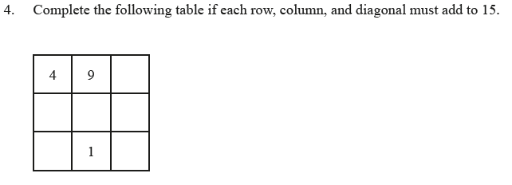

/3

**<>**

/2





**<>**



**<>**

You have completed *Lesson 3.3 Game On!*. Please proceed to the *Unit 3: Logic and Reasoning Time Out*.