2.2 Observation Chart on “Supertoys Last All Summer Long”

|  |  |  |  |  |
| --- | --- | --- | --- | --- |
| **Short Story Title** | “Supertoys Last All Summer Long” | **Author** | Brian Aldiss | |
| **Point of View Complete Answer and Quoted Textual Evidence (including page #)** | | | |
| **Check** the box that describes the point of view from which this story is told. first personobjectivelimited omniscientomniscient |  | | | |
| **Characterization Complete Answer and Quoted Textual Evidence (including page #)** | | | |
| **Character Name (list one only)** |  | | | |
| **Character Types**  **Circle** all that apply. | round dynamic stock antagonist  flat static foil protagonist | | | |
| **Essential Questions Complete Answer and Quoted Textual Evidence (including page #)** | | | | |
| **Check** the box next to the ONE essential question that most applies to this story. What does it mean to live well?What roles do success and failure play in the pursuit of living well?How does integrity, or a lack of integrity, affect one’s ability to live well?What are the benefits to ourselves, or to those around us, in using our skills and talents?In what way can a person change the course of his or her life through a single action? **Explain** in **five to eight** **(5–8) sentences** answer this essential question based upon your reading of this story**, explain how it applies to this story**, **and Include at least two quotations, along with page numbers,** from the story to support your ideas about the essential question. |  | | | |
| **Theme Statement** | | | | |
| **Write** a one-sentence theme statement that captures the story’s message about the human condition or insight into life. |  | | | |

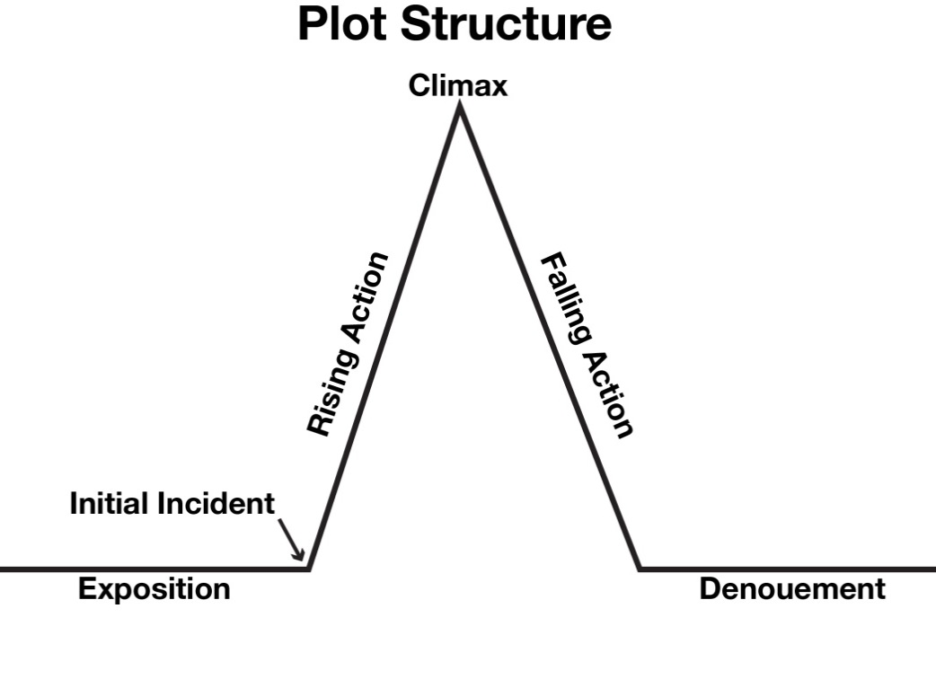

**Plot Structure**

|  |  |
| --- | --- |
| **Exposition Complete Answer and Quoted Textual Evidence (including page #)** | |
| **Explain** what essential information regarding setting, mood, or characters is introduced in the **exposition** of this story? |  |
| **Explain** what **antecedent events** are included, if any? These are events that occurred before the main story began and provide background for the story. |  |
| **Initial Incident Complete Answer and Quoted Textual Evidence (including page #)** | |
| **Describe** the **initial incident** and the **primary conflict** it introduces. |  |
| **Climax Complete Answer and Quoted Textual Evidence (including page #)** | |
| **Identify** the story’s **climax** and **explain** why it is the highest point of tension and/or the turning point in the story. |  |
| **Denouement (Resolution) Complete Answer and Quoted Textual Evidence (including page #)** | |
| How is the primary conflict resolved, if at all? If it is not resolved, **explain**. |  |