Unit 1 Name:

Date:

1-1 Reader’s Notebook: Viewing Images

**Instructions:**

Answer the questions using the following cartoon.

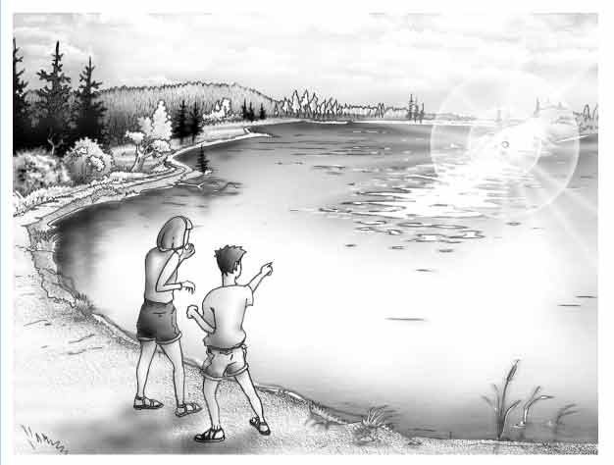

**Observe:**

1. What people are in the picture? (/1)

|  |
| --- |
|  |

**Describe:**

1. How would you describe the people? (/1)

|  |
| --- |
|  |

**Connect:**

1. How does the image make you feel? What detail was used to create that feeling? (/2)

|  |
| --- |
|  |

1. Why did the image catch your attention? **What is the key detail in the cartoon?** (/1)

|  |
| --- |
|  |

1. What makes you remember the image? (Hint: **What kind of line can you identify in the cartoon? And, where is it?**) (/2)

|  |
| --- |
|  |

1. What message does the artist want to emphasize using these details? (/1)

|  |
| --- |
|  |

**Evaluate:**

1. What is the artist’s purpose (tell a story, document an event, make a statement)? (/2)

|  |
| --- |
|  |

1. Use your imagination to consider a story, the picture helped you think about. Write one sentence to begin the story. Write one detail that happens in the middle of the story. Write one ending sentence. (/3)

|  |
| --- |
|  |

Total: /13 marks

**Submit your worksheet to your teacher.**



**Save Your File**

Name your file in this format: jsmith_1-1-viewing-images and save your file to your Documents folder.