Unit 2 Name:
Date:

2-4 Reader’s Notebook: Writing A Biography

Section 1: KWL Chart

Instructions

- Reflect on and share what you learned about fairness and people in the biographies who fought for fairness by completing a KWL chart. KWL stands for What I Know, What I Want to Know, What I Learned.
Complete the first part of the chart (What Do You Know) by identifying what you have learned about fairness in the biographies you have read so far.
In the W section (what you want to learn), place the name of the person on whom you wish to write a biography. This historical person must have fought for fairness.
Leave the L Section blank for now.
Some sample names are as follows.
Science and Medicine | Law and Politicians | Social Issues | WWII
- Edward Jenner  - Joseph Lister  - Louis Pasteur  - Ignaz Philipp Semmelweiss  - Alexander Flemming  - Dr. Charles Ricard Drew  - Florence Nightengale  - Marie Curie | - Solon (Greek lawmaker)  - Justinian I  - Alfred the Great  - Baron Robert Fitzwalter or Archbishop Stephen Langton  - Abraham Lincoln  - William Wilberforce  - Patrick Henry  - Thomas Jefferson  - Benjamin Franklin  - John Diefenbaker  - Lester B. Pearson  - John Humphrey  - Eleanor Roosevelt  - Joseph Brandt  - Nellie McClung | - David Livingstone  - Mahatma Gandhi  - Maewen Succat/Patrick  - Rosa Parks  - Violet Desmond  - Harriet Tubman  - Martin Luther King  - Nelson Mandela  - Sojourner Truth  - Harriet Beecher Stowe  - John Stuart Mill  - Pauline Johnson  - Will Rogers  - Emile Zatopek  - Audrey Hepburn  - Sequoiah  - Chief Dan George  - Hiawatha (Onodaga)  - Helen Keller  - Jane Goodall  - Jesse Owens  - Aung San Suu Kyi | - Winston Churchill  - Anne Frank  - Corrie Ten Boom  - Irena Sendler  - Raoul Wallenberg  - Oskar Schindler  - Dietrich Bonhoffer  - Dr. Jan Karski  - Count Audrey Szeptycki  - Andre Trocome  - Sophie Scholl  - Wladyslaw Bartoszewski  - Dr. Feng Shan Ho

KWL Chart: Making a Difference
K (What Do You Know) | W (What Do You Want to Know) | L (What Have You Learned)
 |  | Leave this section blank.

Total of Section 1: /3 marks

Section 2: BioCube

Instructions
After you have chosen your historical individual, insert text into the template below. You must have six categories.
- Explain the person’s significance to the fight for fairness. Choose 3 key ways they contributed to fairness.
- Describe the obstacle faced and how they overcame it.
- Provide 2 details about the person’s background.
- Add 1 detail about the person’s personality.
- Add 1 famous quotation attributed to the person.

Total of Section 2: /10 marks

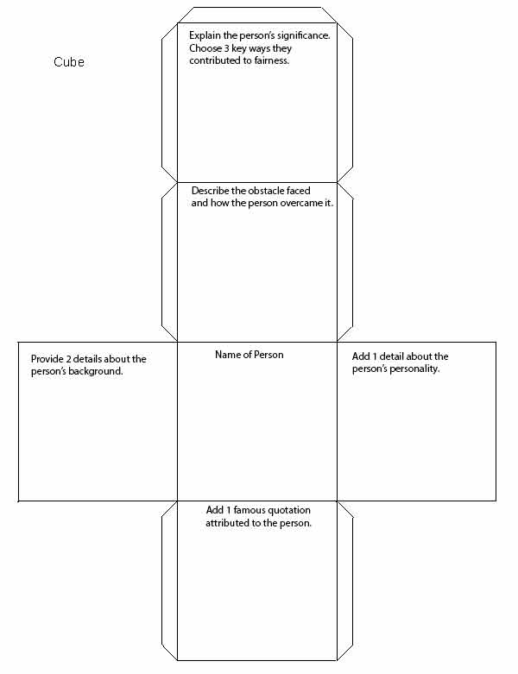

Overall Total: /13 marks


Save Your File
Name your file in this format: jsmithla6_2-4_ bio_plan and save your file to your Documents folder.

