Unit 6 Name:

Date:

6-2 Section 1: Tall Tales

1. What elements of a tall tale does the story “Champlain’s Awesome Adventure” on pp. 165-169 of *Literacy in Action 6B* contain? ( /2 marks)

|  |
| --- |
|  |

1. What elements of a tall tale does the Youtube oral recitation of Johnny Chinook tales contain? <https://youtu.be/6oeDHgeS-rw> ( /2 marks)

|  |
| --- |
|  |

1. Provide two examples of how description of setting is used to develop the tall tale of “The Cremation of Sam McGee”. ( /2 marks)

|  |
| --- |
|  |

1. Which format did you find the most effective method of telling a tall tale (ballad, story, film, or oral)? Explain. ( /2 marks)

|  |
| --- |
|  |

Total of Section 1: /8 marks

Section 2: Tell a Tall Tale

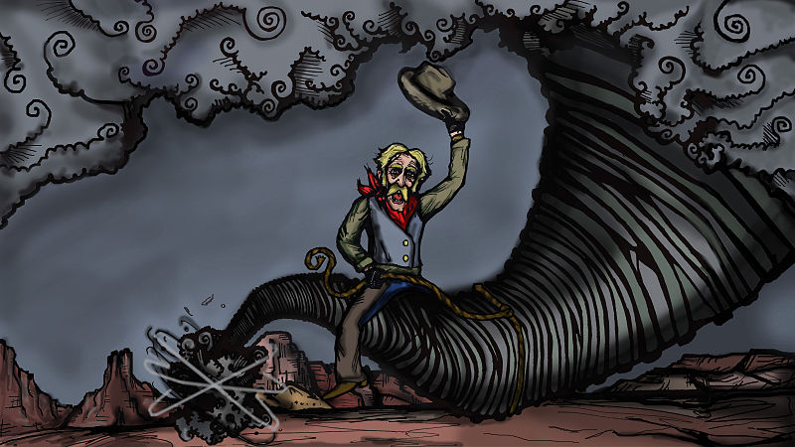

Look at the picture above or on page 125 of *Literacy In Action* 6B.

Use your imagination to tell a short tall tale that the picture has helped you to think about.

You may present the story orally, or in writing. The story may be in poetry (ballad form) or prose.

When telling your story, be sure to

* consider your audience
* focus on your purpose
* organize your thoughts appropriately in sentences and paragraphs
* use vocabulary that is interesting and descriptive
* edit your written work or practice telling your story so that your recitation is smooth and effective, without stumbles

Type your story below. Or, phone your teacher or digitally record yourself.

|  |
| --- |
|  |

|  |
| --- |
| Tall Tale Rubric |

|  |  |  |  |  |  |
| --- | --- | --- | --- | --- | --- |
| Criteria | Excellent  5 | | Proficient  4 | Satisfactory  3 | Limited  2 |
| **Content - Elements of Fiction /5** | * I developed *insightful* ideas. * I provided *compelling* character motivation and conflict. * I used *precise* details to describe setting, character, and plot events. | | * I developed *thoughtful* ideas. * I provided *logical* character motivation and conflict. * I used *reasonable* details to describe setting, character, and plot events. | * I developed *adequate* ideas. * I provided *appropriate* character motivation and conflict. * I used *general* details to describe setting, character, and plot events. | * I developed *vague* ideas. * I provided *underdeveloped* character motivation and conflict. * I used *imprecise* details to describe setting, character, and plot events. |
| **Organization**  **/5** | * I used *effective* order. * I had an *engaging* beginning, *convincing* middle, and *believable* ending. | | * I used *logical* order. * I had an *interesting* beginning, *thoughtful* middle, and *effective* ending. | * I used *basic* order. * I had a *functional* beginning, *acceptable* middle, and *general* ending. | * I used *unsteady* or *confusing* order. * I had an *confusing* beginning, *convincing* middle, and *unrealistic* ending. |
| **Voice: Words and Sentences /5** | * I chose *powerful, meaningful* words. * I communicated *engagingly* with *compelling* sentence variety*.* | | * I chose *strong, thoughtful* words. * I communicated *credibly* with *reasonable* sentence variety. | * I chose *appropriate*, *general* words. * I communicated *clearly* with *appropriate* sentence variety. | * I chose *vague, imprecise* words. * I communicated *unclearly* with *uninteresting* sentence variety. |
| **Presentation /5** | * I communicated *accurately* or with *effective, stirring* pacing, drama, and enunciation. | | * I communicated with *few* errors or with *consistent* pacing, drama, and enunciation. | * I communicated with *some* errors or with *slips* inpacing, drama, and enunciation. | * I communicated with *many errors* or with *ineffective* pacing, drama, and enunciation. |
| **Insufficient** | Your attempt to respond is *insufficient*. **Contact your teacher** to discuss suggestions for improvement. | | | | |
| **Total: /20** | | | | | |
| **Assessment** | | **Areas of Strength:** | | | |
| **Target for Improvement:** | | | |

Total of Section 2: /20 marks

Overall Total: /28 marks

**Submit your worksheet to your teacher.**



**Save Your File**

Name your file in this format: jsmithla6_6-2-tall-tale and save your file to your Documents folder.