**Self-Assessment: Peer Edit of Tyrone's Construct / Destruct**

1. **Read** Tyrone's "Background" and "Rationale" paragraphs and answer the following questions.
2. Identify **five categories** of mistakes in Tyrone's work. Tyrone may have misspelled 5 words; however, that is only one category. Among other categories of mistakes mentioned in your readings are sentence structure, paragraph structure, ineffective word choice, grammar, punctuation, and tense usage.

**(your answer here )**

1. Write the number of the line in which the error appears, and how you would correct it. For example, L 37: Run-on sentence could be split into 2 sentences: "He became well known. People appreciated his art."

**(your answer here)**

1. What kinds of mistakes did you notice most?

**(your answer here)**

1. Why were these mistakes so noticeable to you?

**(your answer here)**

2*.* Three sentences have several errors and do not make sense: lines 1-2, lines 10-15, and line 15.**Re-write** each sentence to repair their mistakes. Consider Tyrone's content carefully when thinking about ways to re-structure the sentences. Split a sentence into more than one sentence if necessary. Correct all punctuation, spelling, **word choice**, or grammar mistakes you see.

*You may add words of your own devising or delete words you think do not work well.*

Line 1-2: Last year or so graffiti and vandalism have common problems in the Cold Lake Tritown area.

**(your answer)**

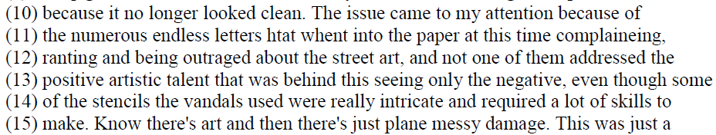

**(your answer)**

Line 15: know there's art and then there's just plane messy damage.

**(your answer)**

1. Identify one example of **redundant** or ineffective **repetitive** word use. Provide a correction.

**(your answer)**

1. Transition words in a paragraph help a reader connect sentences, details, and ideas.

Re-write this paragraph to repair errors in spelling, grammar, word use, and punctuation. Add at least **three** useful transitions of your own.

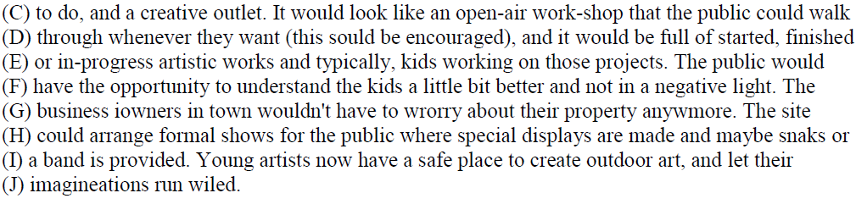

**(your answer)**

1. Find two examples of effective sentences or supporting details in Tyrone's "Background" paragraph. Identify the number of the lines in which they appear, and explain how they are effective in contributing to the paragraph.
2. **(your answer)**
3. **(your answer)**
4. Three sentences found in "Background" could be expanded into paragraphs on their own:



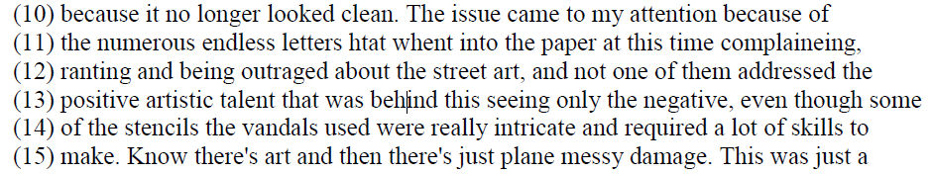



**Choose one** of these three sentences and develop it into a detailed, well-organized paragraph. In your paragraph, fix Tyrone's errors.

**(your answer)**