# 6.2 Character Profile: Planning

Select key words from your notes about your chosen character to respond to the ideas in the Wordle. A Wordle is a graphic composed of key words. These are useful when emphasizing key concepts or ideas of a topic. Wordles can be used to promote brainstorming. You can make these for free at [*www.wordle.net*](http://www.wordle.net/)*.* Write your notes about your novel’s protagonist, responding to the Wordle, below.

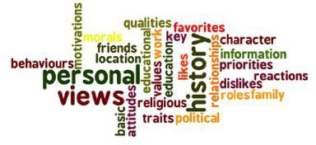

*Courtesy of ADLC*

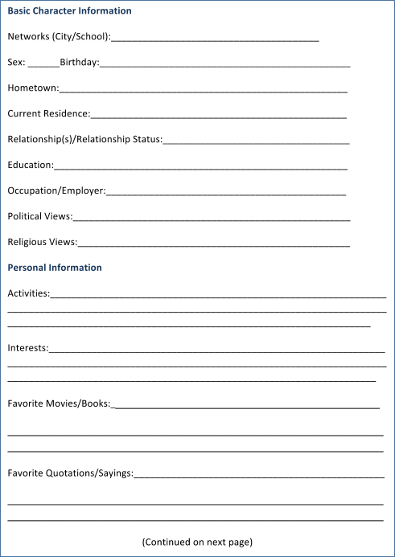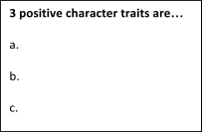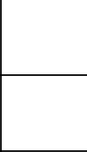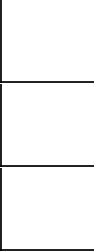

*Facebook image courtesy of Pixabay*

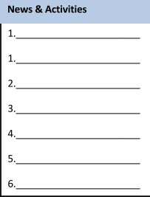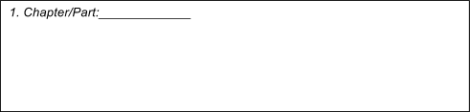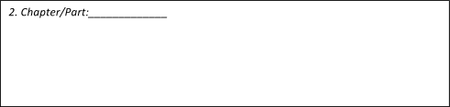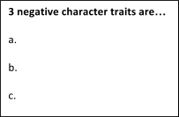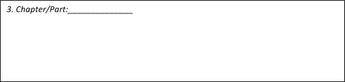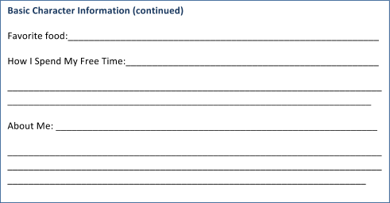

*Facebook image courtesy of Pixabay*

|  |  |
| --- | --- |
| **6.2 Character Profile Assessment** | |
| **Value** | **Descriptor** |
| **Excellent** | * You demonstrate *perceptive* **understanding** of the traits and motivations of characters. * You form *insightful* **predictions** about characters in relation to themes or events. * You provide *precise* **details** and/or **quotations** in support of your ideas. |
| **Proficient** | * You demonstrate *thoughtful* **understanding** of the traits and motivations of characters. * You form *significant* predictions about character in relation to themes or events. * You provide *relevant* **details** and/or **quotations** in support of your ideas. |
| **Satisfactory** | * You demonstrate *adequate* **understanding** of the traits and motivations of characters. * You form *appropriate* **predictions** about characters in relation to themes or events. * You provide *basic* **details** and/or **quotations** in support of your ideas. |
| **Limited** | * You demonstrate *limited* or *confused* **understanding** of the traits and motivations of characters. * You form *superficial* or *implausible* **predictions** about character(s) in relation to themes or events. * You provide *insufficient* or *irrelevant* **details** or **quotations** in support of your ideas. |
| **Resubmission Needed** | Your attempt to respond is *insufficient*. **Contact your teacher** to discuss suggestions for improvement and resubmission of your work. |
| **TOTAL: /20 = %** | |
| **Assessment** | **Areas of strength:** |
| **Might I suggest…** |