**Step #3**  **Put your ideas in order/fill in a planner.**

**Basic Paragraph**

A basic paragraph of any type begins with an introductory sentence to open the topic. It is followed by three or four supporting sentences that explain the idea more or provide evidence for the topic, and a concluding sentence that sums up and closes the topic.

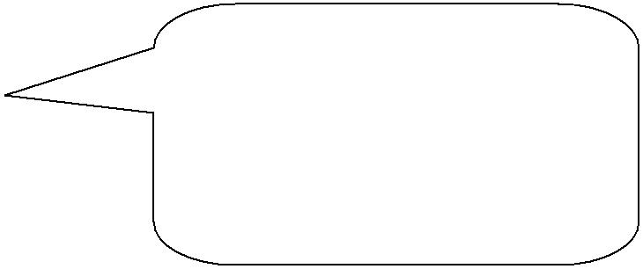

**Time Order Paragraph**

Narrative, descriptive and expository paragraphs can all be written in **time** **order**. This means that the events orsteps are told in **the order that they** **happen**.

**Place Order Paragraph**

Descriptive and expository paragraphs can be written in **place order**. This means that the details are described in **the order that they are found** (fromtop to bottom, left to right, outside to inside).

**Importance Order Paragraph**

**Examples of linking words that show time order:**

**when, first, second, next, then, after, later, until, at, finally, as soon as, meanwhile**

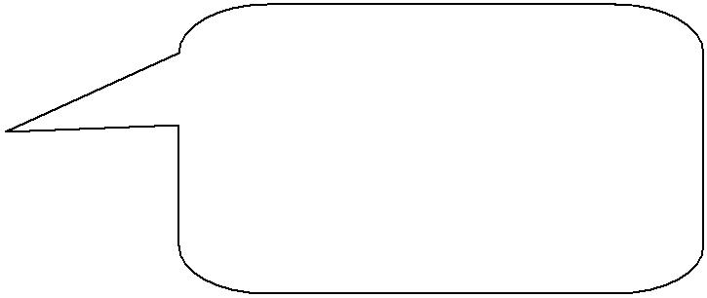

**Examples of linking words that show place order:**

**above, below, between, on, over, near, under, by, against, inside, through**

Persuasive and expository paragraphs, along with narrative paragraphs that tell news stories, can all be written in **importance order**. This means that the paragraph begins with the **most important** or **main idea** and the supporting details are organized from the **most** to **least important**.

|  |  |  |  |  |
| --- | --- | --- | --- | --- |
|  |  |  |  |  |
|  | **Step #4** | **Write a first draft.** |  |  |
|  |  |  |  |  |
|  | **Step #5** | **Revise and edit the first draft.** | |  |
|  |  |  |
|  |  |  |  |  |
|  | **Step #6** | **Write a final draft.** |  |  |
|  |  |  |  |  |
|  |  |  |  |  |
|  | Knowledge and Employability Studio | | Writing/Paragraph Writing/ |  |
|  | English Language Arts | | **Steps for Writing a Paragraph** 2/2 |  |

