Mathematics 10-3: glossary terms

Save a copy of this document in your course folder. This glossary contains all of the terms defined in this module. You will come across the terms as you work through the lessons.

Each time you come across a new term, open the copy of this document that you saved in your course folder. Then add notes, examples, drawings, and so on to the third column.

By the end of the module, you will have your own personal glossary.

Module 5
Term | Definition | Examples/  Notes
Lesson 1
angle | a geometric shape formed by two rays with a common endpoint  Each ray is called an arm of the angle. The common endpoint of the arms of the angle is the vertex of the angle.  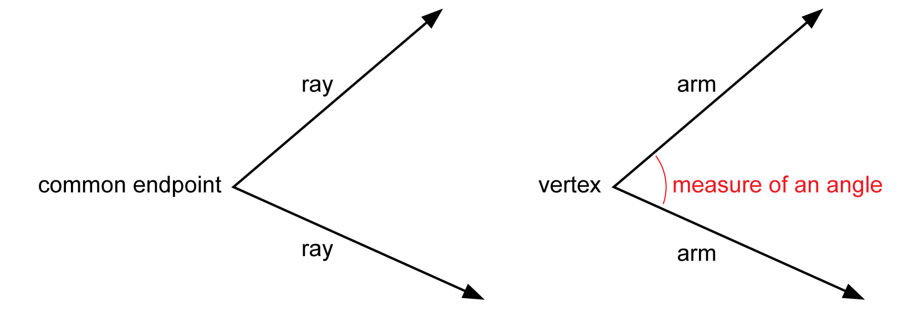
acute angle | an angle greater than 0° but less than 90°  This is an acute angle.  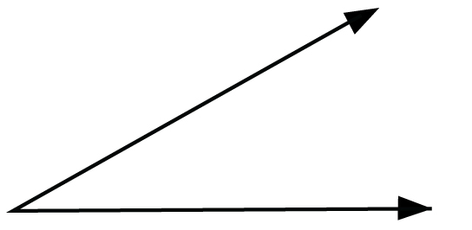
obtuse angle | an angle greater than 90° but less than 180°  For example, this is an obtuse angle.  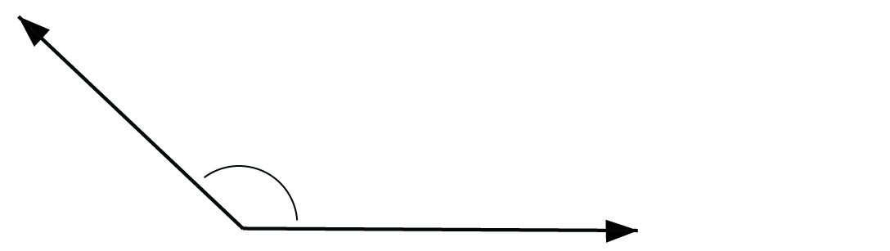
full rotation | an angle having a measure of 360°  This is a full rotation angle.  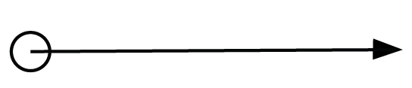
reflex angle | an angle having a measure greater than 180° but less than 360°  This is an example of a reflex angle.  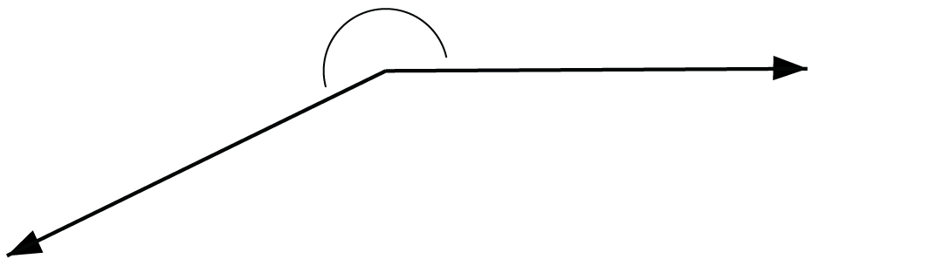
right angle | one-quarter of a complete rotation  It is 90° in measure.
straight angle | one-half of a rotation; an angle of 180°  This is a straight angle.  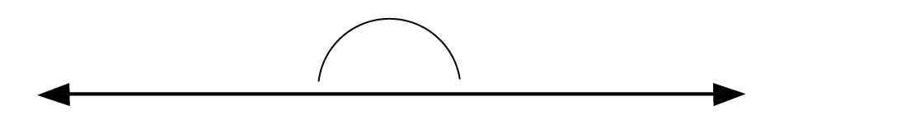
Lesson 2
congruent angles | angles with the same measure  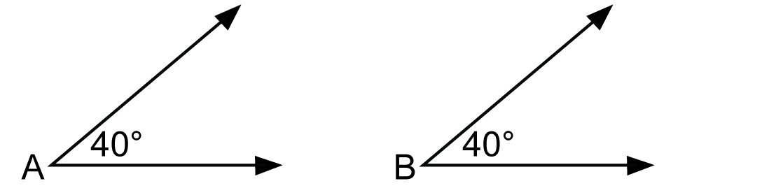  In the diagram,  A = 40° and B = 40°. So, A and B are congruent.  There is a special symbol for “is congruent to.” The congruence symbol is .  So, you can write A B.
straightedge | a rigid strip of wood, metal, or plastic having a straight edge used for drawing lines  When a ruler is used without reference to its measuring scale, it is considered to be a straightedge.
Lesson 3
bisect | to divide into two congruent (equal in measure) halves  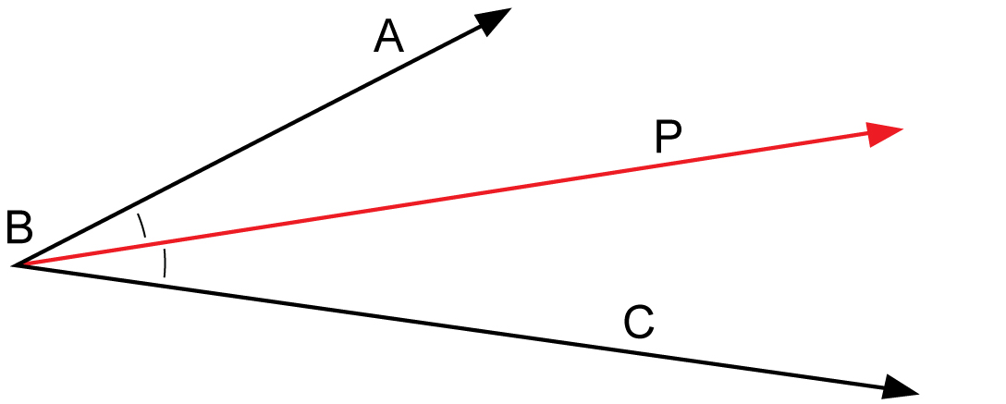
bisector | a line or ray that divides a geometric shape into congruent halves  Ray BP is a bisector of since ray BP bisects into two congruent halves.
symmetry | the property of being the same size and shape on both sides of a central dividing line
Lesson 4
adjacent angles | angles that share a common vertex and lie on opposite sides of a common arm
complementary angles | two angles with measures that add up to 90°  One angle is called the complement of the other.
supplementary angles | two angles that add up to 180°  In a pair of supplementary angles, one angle is the supplement of the other.
vertically opposite angles | angles lying across from each other at the point where two lines intersect  Vertically opposite angles are also referred to as opposite angles.
Lesson 5
alternate exterior angles | exterior angles lying on opposite sides of the transversal—one angle is on the left side and the other angle is on the right side
alternate interior angles | interior angles lying on opposite sides of the transversal—one is on the left side and the other is on the right side
co-exterior angles | exterior angles that lie on the same side of the transversal
co-interior angles | interior angles that lie on the same side of the transversal
corresponding angles | angles in the same relative positions when two lines are intersected by a transversal
exterior angles | angles lying outside two lines cut by a transversal
interior angles | angles lying between two lines cut by a transversal
transversal | a line that cuts across two or more lines

