Mathematics 10-3: glossary terms

Save a copy of this document in your course folder. This glossary contains all of the terms defined in this module. You will come across the terms as you work through the lessons.

Each time you come across a new term, open the copy of this document that you saved in your course folder. Then add notes, examples, drawings, and so on to the third column.

By the end of the module, you will have your own personal glossary.

Module 6
Term | Definition | Examples/Notes
Lesson 1
polygon | a many-sided figure  A triangle is a polygon with three sides, a quadrilateral is a polygon with four sides, and so on.
proportion | a statement showing two ratios are equal
scale factor | the number by which the length and the width of a figure are multiplied to form a larger or smaller similar figure
similar figures | figures with the same shape but not necessarily the same size  A figure similar to another may be larger or smaller than the other.
Lesson 2
regular polygon | a polygon with all its angles equal in measure and all its sides equal in measure
Lesson 5
hypotenuse | in a right triangle, the side opposite the right angle; the longest side in a right triangle  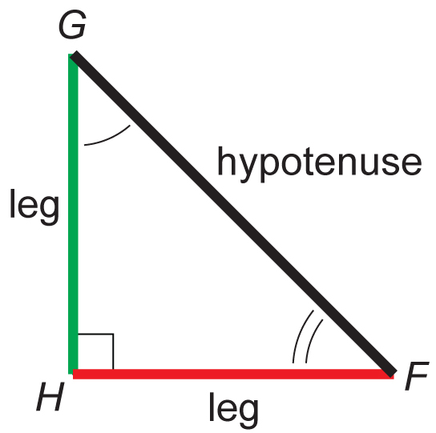
leg | one of the two sides of a right triangle that forms the right angle
Pythagorean Theorem | For any right triangle, the square on the hypotenuse is equal to the sum of the squares on the two legs.
Pythagorean triple | three whole numbers that represent the lengths of the sides of a right triangle  There are an infinite number of such triples.

