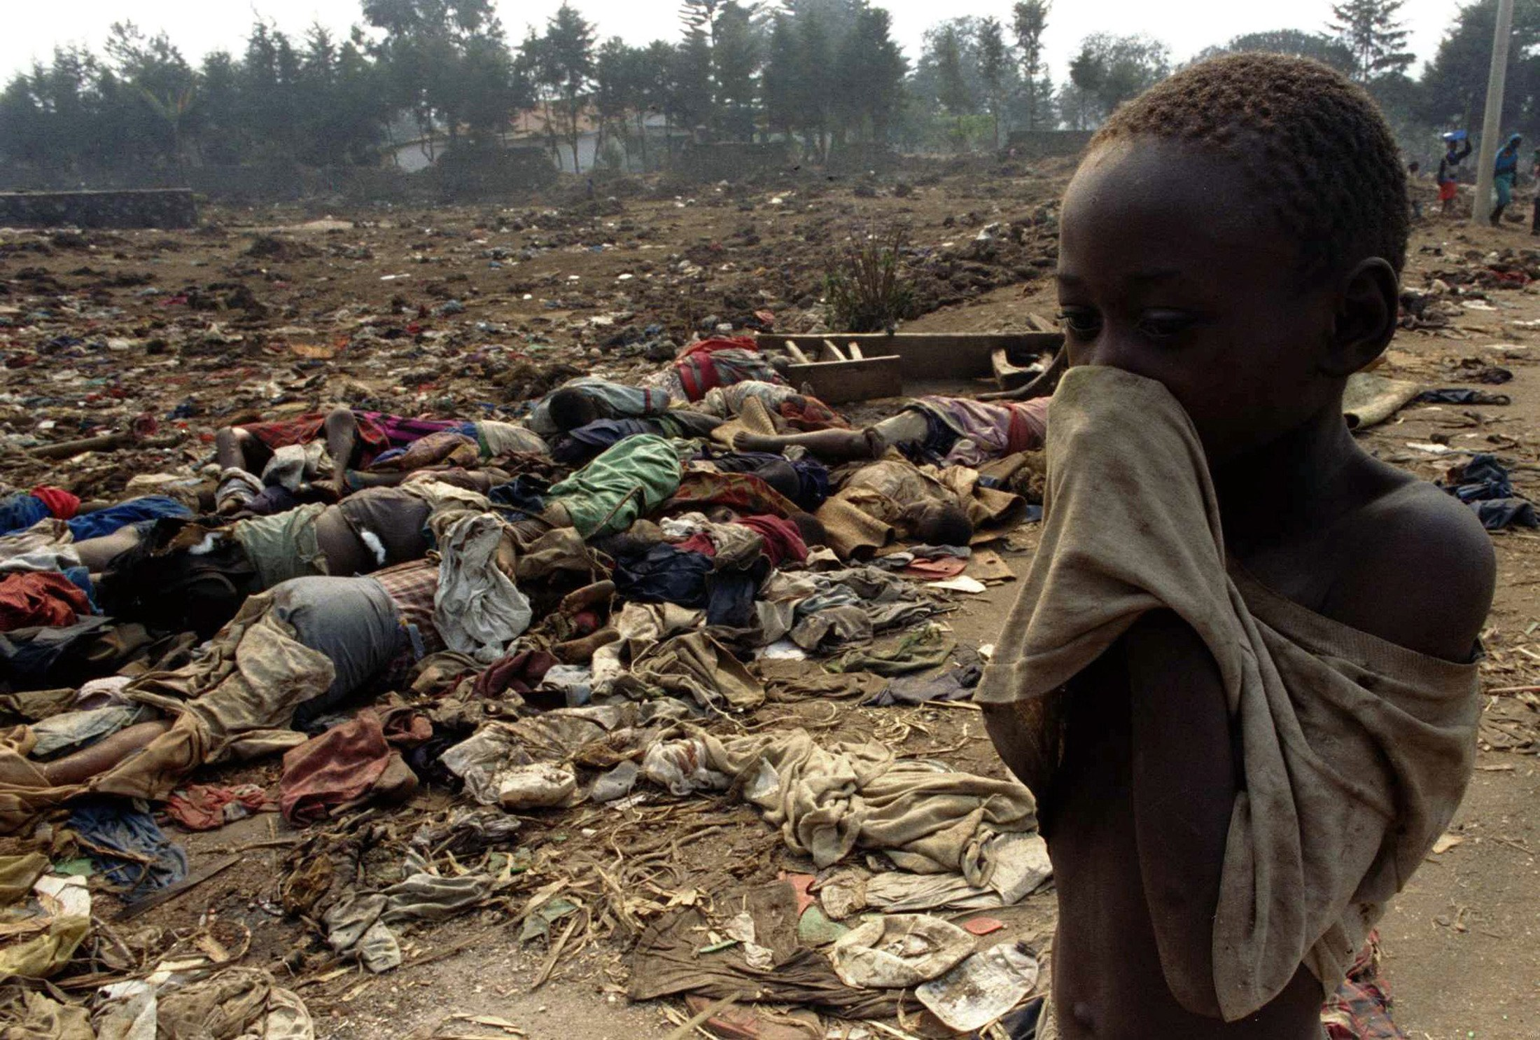Beginning on April 6, 1994, Hutus began slaughtering the Tutsis in the African country of Rwanda. As the brutal killings continued, the world stood idly by and just watched the slaughter. Lasting 100 days, the Rwanda genocide left approximately 800,000 Tutsis and Hutu sympathizers dead.
Who Are the Hutu and Tutsi?
The Hutu and Tutsi are two peoples who share a common past. When Rwanda was first settled, the people who lived there raised cattle. Soon, the people who owned the most cattle were called "Tutsi" and everyone else was called "Hutu." At this time, a person could easily change categories through marriage or cattle acquisition.
It wasn't until Europeans came to colonize the area that the terms "Tutsi" and "Hutu" took on a racial role. The Germans were the first to colonize Rwanda in 1894. They looked at the Rwandan people and thought the Tutsi had more European characteristics, such as lighter skin and a taller build. Thus they put Tutsis in roles of responsibility.
Although the Tutsi constituted only about ten percent of Rwanda's population and the Hutu nearly 90 percent, the Belgians gave the Tutsi all the leadership positions. This upset the Hutu.
When Rwanda struggled for independence from Belgium, the Belgians switched the status of the two groups. Facing a revolution instigated by the Hutu, the Belgians let the Hutus, who constituted the majority of Rwanda's population, be in charge of the new government. This upset the Tutsi.
The animosity between the two groups continued for decades.
The Event That Sparked the Genocide
At 8:30 p.m. on April 6, 1994, President Juvénal Habyarimana of Rwanda was returning from a summit in Tanzania when a surface-to-air missile shot his plane out of the sky over Rwanda's capital city of Kigali. All on board were killed in the crash.
Since 1973, President Habyarimana, a Hutu, had run a totalitarian regime in Rwanda, which had excluded all Tutsis from participating. That changed on August 3, 1993 when Habyarimana signed the Arusha Accords, which weakened the Hutu hold on Rwanda and allowed Tutsis to participate in the government. This greatly upset Hutu extremists.
Although it has never been determined who was truly responsible for the assassination, Hutu extremists profited the most from Habyarimana's death. Within 24 hours after the crash, Hutu extremists had taken over the government, blamed the Tutsis for the assassination, and begun the slaughter.
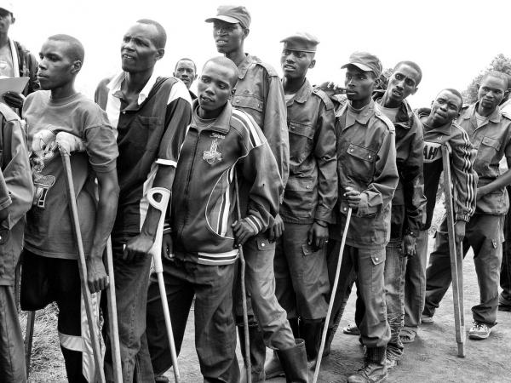
100 Days of Slaughter
The killings began in Rwanda's capital city of Kigali. The Interahamwe ("those who strike as one"), an anti-Tutsi youth organization established by Hutu extremists, set up road blocks. They checked identification cards and killed all who were Tutsi. Most of the killing was done with machetes, clubs, or knives. Over the next few days and weeks, road blocks were set up around Rwanda.
On April 7, Hutu extremists began purging the government of their political opponents, which meant both Tutsis and Hutu moderates were killed. This included the prime minister. When ten Belgian U.N. peacekeepers tried to protect the prime minister, they too were killed. This caused Belgium to start withdrawing its troops from Rwanda.
Over the next several days and weeks, the violence spread. Since the government had the names and addresses of nearly all Tutsis living in Rwanda (remember, each Rwandan had an identity card that labeled them Tutsi, Hutu, or Twa) the killers could go door to door, slaughtering the Tutsis.
Men, women, and children were murdered. Since bullets were expensive, most Tutsis were killed by hand weapons, often machetes or clubs. Many were often tortured before being killed. Some of the victims were given the option of paying for a bullet so that they'd have a quicker death.
Also during the violence, thousands of Tutsi women were raped. Some were raped and then killed, others were kept as sex slaves for weeks. Some Tutsi women and girls were also tortured before being killed.
The World Stood By and Just Watched
Following World War II and the Holocaust, the United Nations adopted a resolution on December 9, 1948, which stated that "The Contracting Parties confirm that genocide, whether committed in time of peace or in time of war, is a crime under international law which they undertake to prevent and to punish."
Clearly, the massacres in Rwanda constituted genocide, so why didn't the world step in to stop it?
There has been a lot of research on this exact question. Some people have said that since Hutu moderates were killed in the early stages then some countries believed the conflict to be more of a civil war rather than a genocide. Other research has shown that the world powers realized it was a genocide but that they didn't want to pay for the needed supplies and personnel to stop it.
No matter what the reason, the world should have stepped in. They should have stopped the slaughter.
The Rwanda Genocide Ends
The Rwanda Genocide ended only when the RPF took over the country. The RPF (Rwandan Patriotic Front) were a trained military group consisting of Tutsis who had been exiled in earlier years, many of whom lived in Uganda.
The RPF were able to enter Rwanda and slowly take over the country. In mid July 1994, when the RPF had full control, did the genocide stop.

QUESTIONS to consider:
1. Which group...the Hutus or Tutsis were seen as "superior" by the Germans and why? What were they given as a result?
2. What did the Belgians do that upset the Tutsis and why? Can you understand why they might object to this? Why or why not?
3. What was the event that sparked the genocide, and why did it occur?
4. What events let to Belgium withdrawing its troops from Rwanda?
5. What finally ended the Genocide? Do you think the UN should have stepped in to stop the crisis earlier? Why or why not?

