Guidelines to Success
Read the content, then answer the questions located
within the ‘Introductory Assignment’ link.
Submit your questions and answers to the U1 Course Intro folder, in moodle.

Teacher: W. Burr
Phone: 403-945-4000 (ext. 5363)
Email: wburr@rvschools.ab.ca
Office Hours: Mondays 12:00-12:30Communication -
Email your teacher to establish contact. Email and course announcements are our main form of communication, so check your RVS email account daily!
Email -
manners and clarity – when emailing your teachers remember we receive and answer dozens of emails every day. For this reason, begin your email with a polite salutation (ex: Hi Mrs. Burr). Then identify the course subject, the current unit of study and the lesson that you are inquiring about. This makes communication much clearer.
Be sure to email your teacher from your RVLC email account. Emails from other accounts may be filtered as junk email.
Calendar -
All due dates for assignments and exams are clearly outlined in the course Calendar This is located in the left hand column of your course homepage. Be sure to refer to it daily. (see image below)

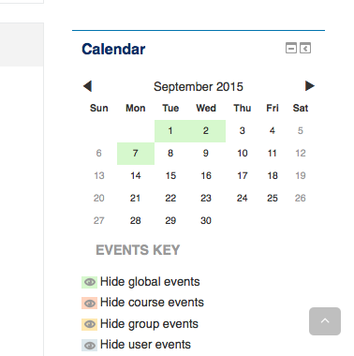

Assignments -
Correctly label all assignments as follow the unit#_lesson#_last name.
Ex labelling for Social 20, Unit One, Lesson 3 = U1L3_burr
Exam Procedure -
Most course exams are online and password restricted. To ensure exam integrity, exam passwords will be emailed directly to the learning coordinator who will also supervise the exam.
All full time RVS online students are required to write exams at your local RVS learning center.
COMPLETING THE COURSE:
Due Dates - Go to your course home page and click on the Calendar link. Note the due dates for all of your assignments.
Assignment submission - Complete the work outlined in the LESSON section by the due date listed in the course Calendar. As soon as you have completed the assignment, submit your work to the correct assignment folder (located underneath the lesson (see image, below).
Submit all assignments immediately after completing them, do NOT wait to submit assignments in bulk)
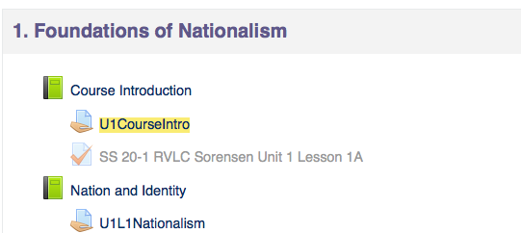

Assignment Feedback - Click on Assignments (located in the right column of course home page).
(See image, below)
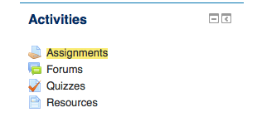

From within the Assignments page, check the feedback in your folders regularly by looking in the Grade column and clicking on any assignments that you have submitted. (see image below)

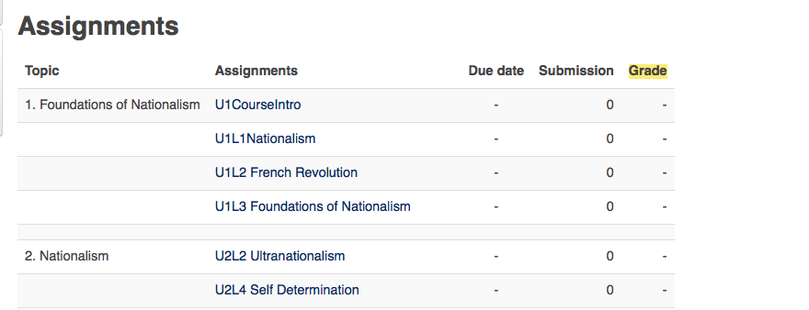

You can also see which assignments are still outstanding by looking in the Submission column. (see image above)
Unit exams - are to be completed after each unit. A test password will be sent to the learning coordinator with specific instructions for administrating the exam. To be eligible for a unit exam, all lessons and assignments, from that unit, need to be handed in.
Final exams dates - will be posted on your course home page. They may also be posted in the Calendar. These exams and exam dates are mandatory and it is your responsibility to know when and where you write. Missing a final test without giving proper notification to your teacher and school administrator may result in a mark of zero.
There are no longer ‘rollovers’ from semester one to semester two, so you need to be sure to complete all course work before the semester end.
When you are unsure of something, whether it is course work or online learning issues, it is important that you ask your teacher for assistance immediately.
All of your teachers are here to help you and want to see you succeed. By following the steps outlined above and keeping in regular contact with your teacher, you will improve your chances of succeeding immensely! Never hesitate to ask for help, and have a great semester! :-)

