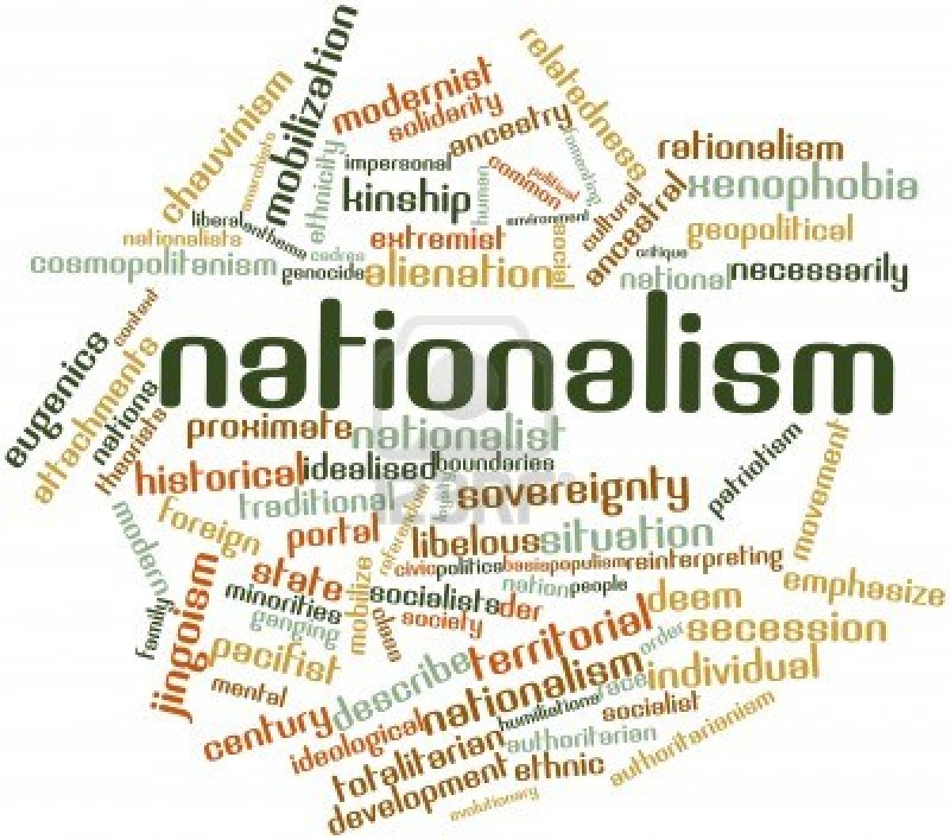
What are Some Understandings of Nation?

Linguistic Understandings of Nation

Many people believe that language helps create a shared worldview that gives people a sense of nation. Language influences how people see the world. It creates a mental universe that is shared by people who speak a language fluently. The people of Quebec feel that because French is the first language of more than 80% of the people that there is a “Quebecois” nation. Many Quebecois share historical, cultural, and religious roots as well. Also, Francophones (French speaking) people from around the world (Haiti, Lebanon, Vietnam) have immigrated to Quebec. In November 2006, Stephen Harper created quite a controversy when he declared that, “the Quebecois form a nation within a united Canada.”

Ethnic Understandings of Nation

Many nations come into being because people share the same ethnic— racial, cultural, or linguistic— characteristics. The Korean, Japanese, Somali, and Norwegian nations, for example, are based largely on ethnicity. Some people like the idea of basing nation on a common identity because it protects a people’s collective identity. Others believe it is dangerous because people may start to hate and fear people they see as “other” leading to racism and intolerance.

Cultural Understandings of Nation

Culture— the ways of life that a people share— can also inspire a sense of nation. Culture is often closely related to ethnicity but that is not always the case. In Canada, for example, First Nations have very different cultures from each other.

Religious Understanding of Nation

Religion can also form an important understanding of nation. The Jewish nation, for example, has existed for 3000 years even though for most of this time they did not have a country of their own. Many Jews speak different languages, have different ethnic backgrounds, and have different cultures.

Geographic Understandings of Nation

When you compare a political map of the world with a map that shows only physical features you will see the effects of geography on the development of nations. Mountains, oceans, deserts, and rivers are physical barriers that have separated people. Often people develop distinct identities in isolation. Tibet is an example of a nation that developed in isolation for thousands of year because of the surrounding mountains. Tibet developed it’s own language, culture, religious beliefs, and government. Different geographic areas also provide different resources, which influence the way people live.

Spiritual Understandings of Nation

There is often a spiritual connection that develops between people and place.
The spiritual connection people have with a land is often directly related to sacred sites that are an important part of a people’s spiritual identity. Jews, Christians, and Muslims all feel Jerusalem is a holy city.

Political Understandings of Nation

Many people believe that when deciding whether a people are a nation, the desire for self-determination (the power to control one’s own affairs) is an important factor. This desire may be more important than actual sovereignty (independence). Tibetans do not currently enjoy sovereignty because they are controlled by China. However, Tibetans do desire self-determination and were (arguably) independent for over two thousand years.

