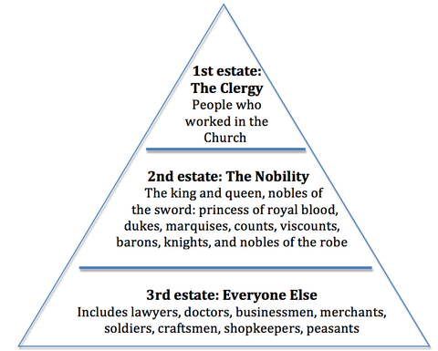
A. The Estates System
- First Estate: The Clergy
1% of pop, with 10% of land.They had wealth, land, privileges and they levied a tax on the peasantry, the tithe, which generally went to some remote bishop or monastery rather than the local parish priest.
The First Estate was perhaps 100,000 strong. But note that there were many poor clergymen in this Estate, and they were going to support the Revolution.
- Second Estate: The Nobility
2-5% of pop, with 20% of the land. They also had great wealth and taxed the peasantry: There was a "feudal" resurgence in 18th century.
400,000 people.
- Third Estate: Everyone Else
95-98% of the pop.
There were some few rich members, the artisans and all the peasantry. These were also class divisions.
In the modern world we only consider the Third Estate. Its Victory has been total.
B. Subdivisions of the Third Estate
- The Bourgeoisie
8% of the pop, about 2.3 Million people, with 20% of Land. They often bought land and exploited the peasants on it. In Third Estate, the most important group politically was the Bourgeoisie. The Bourgeoisie had been growing throughout the century, to some extent encouraged by the monarchy. By 1788 it was very important and its members were well read, educated and rich (fivefold increase in trade 1713 -1789). But this important group had no say in running the country.
- The Peasants
with 40% of the land, formed the vast majority of population. There was population growth in this period: perhaps 3,000,000 people added over the century. Peasants paid the most tax: aristocrats did not pay. Peasants alone paid the taille. They alone had to give labor service to the State. They also had to pay the tithe, in kind, to the clergy.
As well as these taxes, peasants had to give services to their Landlords: this is sometimes called `feudal' service. They also pay dues to their feudal (seigniorial) lord when they sold land that was in all other ways their own. Poverty was intense, but varied by region.
Peasants farmed the land, and regard it as their own, but it was not legally theirs. What they wanted was to own their own property.
- The Urban Poor of Paris
Artisans - factory workers, journeymen. They very poor were probably less involved in politics. Artisans had different interests than the bourgeoisie. but they played an important role at several points. They were the most politicized group of poor people, possibly due to high literacy.
[Note on Literacy: Literacy was comparatively high amongst all classes in northern France. This had the effect that everybody could imbibe the new ideas that came out in pamphlets. ]
