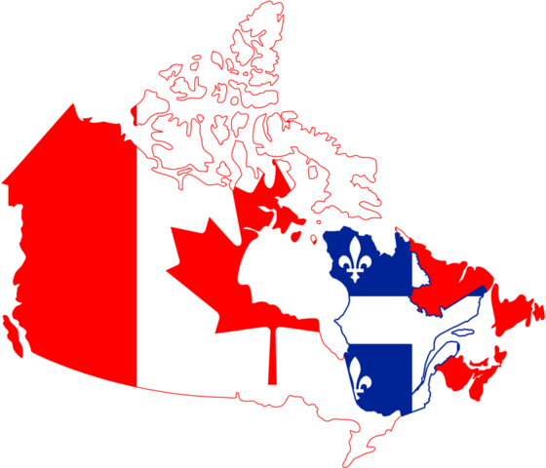What is Quebec Nationalism?
HISTORY OF QUEBEC NATIONALISM
Founded in 1608, Quebec City became the capital of New France. During the French regime, the fortified city was an important centre of trade and development. Today it is regarded as the cradle of French civilization in America.
French - British rivalry in North America led to the Seven Years' War, which saw the fall of Quebec City to British forces in 1759. With the Treaty of Paris in 1763, New France became a colony of Britain. In 1774, under the Quebec Act, Britain granted official recognition to French Civil Law, guaranteed religious freedom and authorized the use of the French language.
In 1791, the colony was divided in two to reflect the large immigration of Loyalists who, wishing to remain British subjects, fled north after the American Revolution to settle in western Quebec. This led to the creation of Upper Canada (now Ontario) and Lower Canada (Quebec). After rebellions in both regions in 1837, the two were modified by the Act of Union, 1840 and became the Province of Canada. In 1867, Quebec became a founding member of the new Dominion of Canada.
Historically, Quebec's rural and Catholic roots made it a traditional, agrarian (agricultural) society. With the rise of the second industrial revolution between 1920 and 1940, urbanization and higher living standards came to the province.
Beginning in 1960, Quebec entered yet another period of transition: the "Quiet Revolution." It was marked by rapid economic expansion, cultural pride and a revamping of public-sector institutions to meet the needs of contemporary society. The Quiet Revolution was also the beginning of a new period of political tension as the province sought to assume greater control over its economy and institutions.
In 1980, a provincial referendum was conducted on negotiating an arrangement for sovereignty association with Canada. The referendum was defeated by a majority of Quebec citizens (51%-49%), as was a second referendum held in 1995.
Less than a month after the Quebec sovereignty referendum of October 30, 1995, the Parliament of Canada passed a resolution recognizing Quebec as a distinct society.
Throughout Quebec's history, the survival of the "French fact" in Quebec has been central to the concerns of Quebeckers. It is this very aspect that reflects Quebec's distinct place in the Canadian Confederation and gives Canada much of its bilingual character and cultural richness.
Introduced by Camille Laurin, Bill 101, (1977), made French the official language of government and of the courts in the province of Québec, as well as making it the normal and habitual language of the workplace, of instruction, of communications, of commerce and of business. Education in French became compulsory for immigrants, even those from other Canadian provinces, unless a "reciprocal agreement" existed between Québec and that province (the so-called Québec clause).

A controversial Quebec Charter of Values was proposed in 2013, which has been very controversial.
The proposal would ban “overt and conspicuous” religious symbols by government employees
• Would make it mandatory to have one’s face uncovered while providing or receiving a state service
• Quebec will entrench the concept of religious neutrality in the Quebec Charter of Rights and Freedoms

