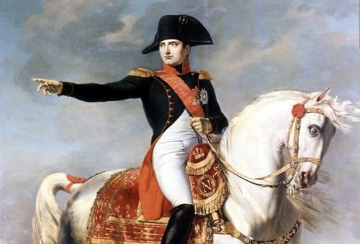WHO WAS NAPOLEON BONAPARTE?
Napoleon is both a historical figure and a legend—and it is sometimes difficult to separate the two. The events of his life fired the imaginations of great writers, film makers, and playwrights whose works have done much to create the Napoleonic legend.
Napoleon was born on the Island of Corsica, off the coast of Italy. He rose from humble origins to become Emperor of France. At the age of five, he was sent to a school for girls! His mother hoped he would become less stubborn and easier to handle. Napoleon, who was the second of eight children, was strong-willed, obstinate and often disagreeable.
As a student, Napoleon loved reading books of all kinds. When he was finally accepted to a French military academy and later to the Military College of France, his reading skills helped him rise to the top of his class.
Napoleon's career was a fast rise from poverty to power, and then to almost as quick a fall. His military conquests threatened the stability of the world. Napoleon was one of the greatest military commanders in history. He has also been portrayed as a power hungry conqueror. Napoleon denied those accusations. In the states he created, Napoleon granted constitutions, introduced law codes, abolished feudalism, created efficient governments and fostered education, science, literature and the arts.
While Napoleon believed in government "for" the people, he rejected government "by" the people. His France was a police state with a vast network of secret police and spies. The police shut down plays containing any hint of disagreement or criticism of the government. The press was controlled by the state. It was impossible to express an opinion without Napoleon's approval.
When Napoleon was finally defeated by the English at Waterloo in 1815, Napoleon was made a prisoner and taken to St. Helena, an isolated island in the South Atlantic.
At first, Napoleon tried to make the best of things, but in time he became bored and irritated. Napoleon tried to work and dictate his memoirs, but ill health dogged his footsteps. His legs swelled, his energy left him. He knew death was not far away. He wrote a will in which his last request was that his ashes might rest on the banks of the Seine River. Napoleon died at the age of 52 years, which wasn't that unusual in those days, but it took 20 years for his body to be returned to France!
ANALYZING WHAT NAPOLEON DID FOR FRANCE
*In 1802, he brought victory to France and peace to Europe
*Napoleonic Code - centralized government, included many democratic principles such as religious freedom, jury trial, outlawing serfdom and fair legal methods.
*University of France - set the pattern for modern dictators by making sure schools taught what he wanted them to!
*Bank of France - Napoleon organized the bank, efficiently collected taxes, and encouraged business
*Concordat - agreement with the pope to once again make the Catholic Church official in France. In exchange, the pope gave up all claims to lands taken from the Church by the National Assembly.
*Improvements to France - public works, improved roads, dug canals, etc.
Napoleon, with the support of the French people, became First Consul for Life. In reality, he became a dictator, who wished to conquer foreign lands.

