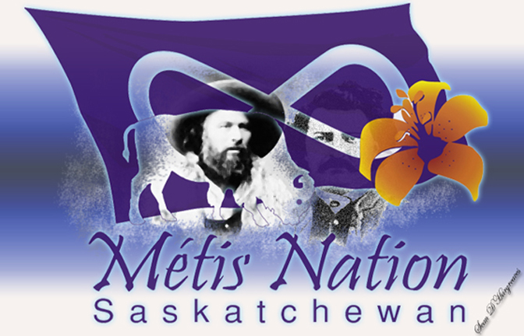 THE HISTORY OF METIS NATIONALISM
Who are the Metis? The word "METIS" comes from the Latin miscere, meaning "to mix"; and was used originally to describe the children of Indian mothers and European fathers.
The Metis are a mixed blood people, the joining of two worlds ... the old world (Europeans) and the new world (North American Indians) ... creating a totally new nation or race of people. There are certain things necessary to be recognized as a distinct nation of people ... from food, clothing, flag, history, political movement. All these criteria and more were met by the Metis people long before the creation of Canada and the United States. However, historic records show that the Metis were often overlooked, exploited, exterminated or cheated out of their rights. Shunned and left out by both the Indians and Whites, the Metis people were distinct in their behaviour, their attitudes and their choice of defining themselves.
Many years ago, as beaver pelts became difficult to find in eastern regions, fur traders were forced to go farther north and west. Contact between cultures, and the intermarriage of Native people and traders, brought significant changes to the economic and social fabric of the land, including the birth of a unique Metis culture on the plains of southern Manitoba.
As French fur traders were integrated into Cree and Ojibwa communities in the Upper Great Lakes region, the population became increasingly racially mixed. A similar situation developed to the north, around Hudson Bay, as children were born from relationships between Irish or Scottish traders and Cree women. In the late eighteenth century, these people moved into the western and northern interior of the country, giving rise to the Metis nation. They adopted elements from both sides of their heritage to become a distinct culture that began to crystallize in the early nineteenth century.
The majority of the Métis people settled in the Red River area. Three main groups emerged -- buffalo hunters, traders, and voyageurs. In 1869 there were over 9,000 Métis. This compared with only 1,600 Europeans and Canadians in Red River.
The area was originally controlled by the Hudson's Bay Company until they sold a majority of their rights to Rupert's Land to the new Dominion of Canada in 1869.
The Métis resisted the take-over of their homeland by the Dominion Government. They seized Upper Fort Garry and its contents of cannons, arms and food supplies, leading to what is known today as the Red River Resistance.
A Provisional Government was formed, lead by Louis Riel, who set out for Ottawa to negotiate for Métis rights.
Negotiations in Ottawa resulted in agreement that the Red River settlement would enter Confederation as a new Province of Manitoba. Manitoba became a province in July, 1870, through the passing of the Manitoba Act.
The Métis kept existing land holdings in Red River and were guaranteed a 1.4 million acre land grant to be reserved for Métis children.
Not long after passing the Manitoba Act, Sir John A. Macdonald proceeded to send a military expedition to Red River to establish control over the new province. With the arrival of the military, Louis Riel fled to American territory to live in exile.
The government then tried to get the Metis to give up their land for a fraction of its worth. Two thirds of the Métis people had moved out of the Province of Manitoba by 1884. Some relocated to the north and the USA. A majority moved to Saskatchewan and Alberta. The Métis resumed their demands for a land base in the Northwest; however, the federal government again ignored their petitions.
The Métis were expected to apply for land as homesteaders. They wanted to settle on the land as a group. However, the government wanted to avoid large concentrations of Métis people in one area. Frustrated, the Métis turned again to Louis Riel.
By the spring of 1885, the Canadian Government through the military engaged the Métis of Batoche into battle. Louis Riel and Gabriel Dumont were appointed leaders who helped the Métis resist the military. This conflict is known today as the Northwest Resistance.
After the Resistance, land grants and scrip were given to the Métis of the Northwest between 1876 and 1921 under the provisions of the Dominion Lands Act. Again, most of the Métis parted with their land and money scrip for a fraction of its true value. While some Métis voluntarily relinquished their scrip, the majority parted with theirs through force or illegal methods.
The Metis, who see themselves as a distinct nation within Canada, have a long heritage that has been troubled and sometimes violent.

