What are Non-Nationalist Loyalties?
Everyone’s identity contains individual and collective loyalties. Some of your collective loyalties may be nationalist, and some may be non-nationalist. A non-nationalist loyalty does not involve nation. Loyalties to your family or to the belief that animals must be treated humanely are examples of non-nationalist loyalties.
Like any type of loyalty non-nationalist loyalties can change. The dividing line between nationalist and non-nationalist loyalties is not always clear. Friends are an example of a non-nationalist loyalty, but if you choose your friends because they come from Lebanon and share the same language and culture there is also a shared nationalist loyalty. Religious, regional, cultural, ethnic, and class loyalties can all be non-nationalist. However, overtime these loyalties can develop into the kind of collective consciousness that becomes a nationalist loyalty.
How do Nationalist and Non-Nationalist Loyalties Contend?
Just as different nationalist loyalties can compete, so can nationalist and non-nationalist loyalties. Conflict can occur whenever there are competing goals.
When Class and Nationalist Loyalties Compete
Most societies are divided either formally or informally into social classes. People are divided into classes based on what they do for work or by their wealth, education, ancestry, etc. If people accept these divisions no conflict will occur. If people reject the inequality (like in the French revolution) conflict may result.
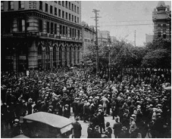
The Winnipeg General Strike
When Religious and Nationalist Loyalties Compete
Due to globalization and worldwide migration, our school includes students with different religious beliefs. Canada is a civic nation where freedom of religion is guaranteed in the Charter of Rights and Freedoms. As a result, people with various religious loyalties are expected to respect each other’s beliefs and coexist peacefully. In many other countries religious and nationalist loyalties have led to conflict.

The “Troubles” of Northern Ireland
When Regional and National Loyalties Compete
A region may be an area within a country (like the West), an area within a province (like northern Alberta), or even an area that crosses provincial and national boundaries (like the prairies). People often express their regional loyalty by actively promoting the interests of their region. But this loyalty can clash with their national loyalties. This is what happened with Alberta in the 1970s.


The National Energy Program

Oil Sands Industry
How Have People Reconciled Nationalist and Non-Nationalist Loyalties?
What can people do when their National and Non-National loyalties are in competition? People can:
• Live with their contending loyalties
• Choose one Loyalty over another
• Accommodate non-nationalist loyalties by bringing about change in the nation
Living with Contending Loyalties
When loyalties compete people may choose to remain uninvolved for many reasons. They may:
• Be undecided on how to respond
• Believe that doing nothing is easier than speaking out or taking action
• Believe that as individuals, they can’t make a difference
• Be occupied with other concerns
The price people pay for their silence is that someone else may end up making important decisions for them.
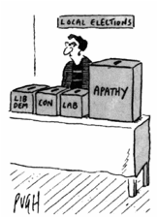
Choosing One Loyalty over Another
When people decide to choose one loyalty over another they may lose an important part of their identity. This leads to feelings of alienation – of being on the outside or left out. When people feel they have to hide or suppress their beliefs they will have a hard time feeling as if they belong to their nation.

The Falun Gong Spiritual Movement
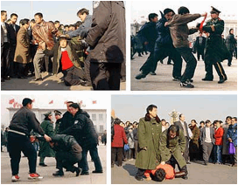

Falun Gong is outlawed in China. Followers will be arrested and possibly tortured.
Accommodating and Bringing about Change

The “Little Rock 9” are an example of people who have fought to bring change.
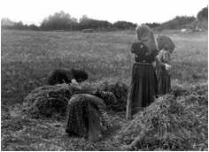
Hutterites do not willingly have their picture taken as part of their beliefs. Should we allow them to have drivers licenses without a photo?


Maher Arar has fought to be treated the same as anyone else in Canada.

