SS202 Unit 1 Source Analysis
In addition to doing additional research, be sure to reference your notes and course content as you complete this assignment.
INSTRUCTIONS:
Open and print the social studies Guide to Analyzing Sources (located within Source Analysis Assignment)
Examine each source below. Write an essay (multi paragraph) response in which you must:
- Interpret each source below
- Explain the perspective (s) in each source and relationship that exists among the sources.
- Demonstrate your understanding of how each source links to identity and nationalism.

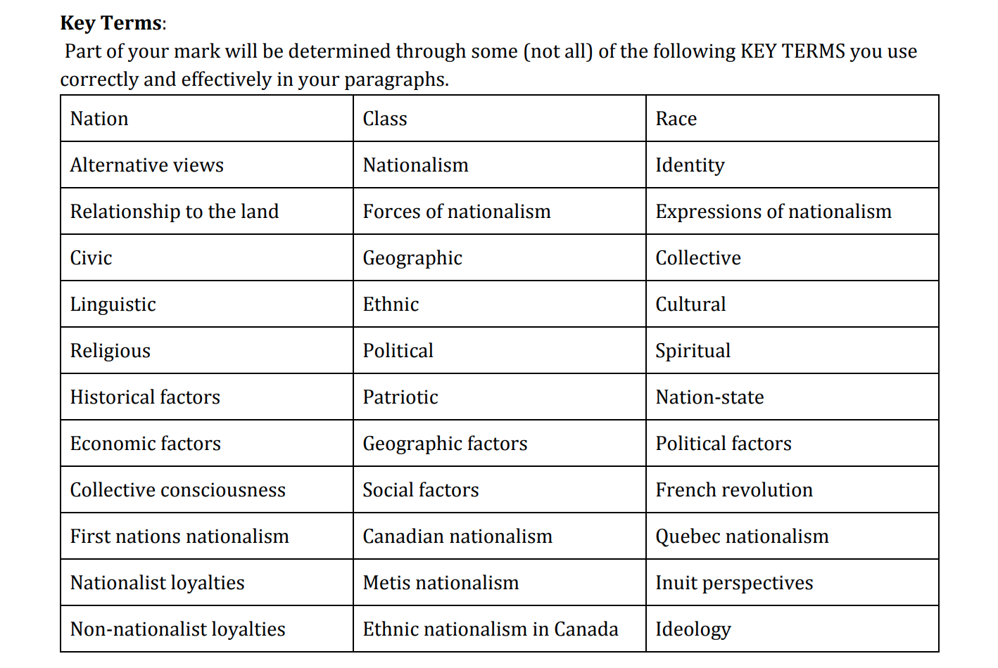
It is important to understand that it is very challenging to effectively include all of the KEY TERMS listed in the table, above. However, the more terms you do use effectively in your response, the better you will demonstrate your understanding and the higher you will score.

SOURCE ONE:
In the end, nation shapes all of us. We may not share all the same ideas, beliefs, values or opinions on everything, but the way we respond to some things today occurs because of all the other identities we were exposed to through nations.
SOURCE TWO:


SOURCE THREE (on next page)…


Source Analysis Guideline (write in essay format)
Paragraph 1 - identify the main issue being discussed
Paragraph 2 - analyze source #1 and demonstrate your understanding of the perspective(s) reflected in it (ie: its links to identity and nationalism)
Paragraph 3 - analyze source #2 and demonstrate your understanding of the perspective(s) reflected in it (ie: its links to identity and nationalism)
Paragraph 4 - analyze source #3 and demonstrate your understanding of the perspective(s) reflected in it (ie: its links to identity and nationalism)
Paragraph 5 - Detail, in paragraph format, the similarities and differences between the sources and how each of the sources links to identity and nationalism

