SS20-1 Ch. 5 National Interest and Foreign Policy

How are nationalism and national interest related?
- Sometimes figuring out the course of action is a matter of personal choice.
- Your choice is not always independent.
- You cannot always base your decisions on what only benefits you.
- Other things can affect your choices like your family’s financial resources, the needs of your wider community, or your need for financial security.

Aspects of National Interest
- Like individuals, people who govern democratic communities and nations make decisions based on what is in the community’s or nation’s interests.
- They want certain benefits for themselves and the community, these include:
- Economic Prosperity – this includes stable employment and a decent standard of living.
- Security and Safety – measures to maintain national security and physical protection.
- Beliefs and Values – these include affirming and promoting citizens values, beliefs and culture.
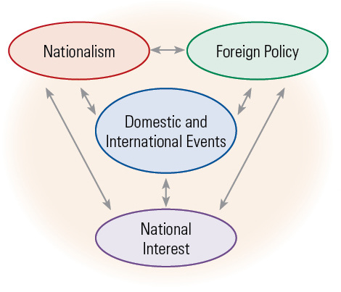
Changing Views of National Interest
- National interest is not static or unchanging, a catastrophic storm or the loss of essential industry can change people’s opinion.

Differing Views of National Interest
- People often decide what is in the national interest based on their understanding of nation and the national identity.
- In other countries people’s ideas about the national interests often demand a strong military that can defend the country’s interests against hostile forces.

National Interest and Arctic Sovereignty
- National interest often involves claiming sovereignty over territory.

National Interests after World War I
- Once World War I ended many Canadians turned their attention to domestic concerns.

- The war created an industrial boom which then died out leaving few with jobs.

How has national interest shaped foreign policy?
- A policy is a plan of action that has been deliberately chosen to guide or influence future decisions.
- A country’s government is responsible for developing both domestic policy and foreign policy.
- Domestic Policy – guides decisions about what to do within the country.
- Foreign Policy – guides decisions about official relations with other countries.

National Interest and World War I Peace Settlements
- Many historians believe that nationalism and people’s beliefs about their national interest were important causes of World War I.

Treaty Negotiations in France
- World War I was fought over sovereignty and territory, economic interests and security, and nationalism and national identity.

National Interests after World War I
- Once World War I ended domestic issues became more important than foreign policy concerns.
- A similar shift in priorities took place in many other countries that had been involved in the war.

Nationalism and national interests in the Middle East
- During the war, Arab Nationalism had been growing their goal was self government. To make this dream possible they helped the Allies and in return they were promised an independent homeland.
- As the Prince was helping Britain, he did not know that Britain and France had secretly agreed to divide up the Middle East and control it themselves.

Treaties in the Middle East
- The Allies were only concerned with their own national interest.
- Since the Middle East was rich in oil, France and Britain believed that controlling much of the Middle East would promote their nationalist interests by securing trade with the region.
- After the war, a nationalist party led by Mustafa Kemal set up a republic in Turkey; the new government refused to accept the European peace treaty and won independence for Turkey.

How has foreign policy shaped national interest?
- A government’s policy can affect its citizen’s safety and security, their economic future, and even their values and culture.

Foreign Policy and Contending National Interests in Peru
- In 2007, the Peruvian government decided that I would be in the national interest to auction land in the Amazon rainforest to foreign-owned oil companies for development.
- The money made by the oil exploration/extraction was to help the Peruvians.
- A group of Indigenous people called the Mascho Piro did not want to move out of the land in question and they also didn’t want to become part of the outside world.
- In September 2007, the Peruvian government signed a contract saying that Indigenous peoples have the right only to territories and resources they have traditionally owned, occupied, and used, but also to own, use, develop, and control territories and resources that they possess by reason of traditional ownership or other traditional occupation or use.

9/11 and Canada in Afghanistan
- As part of its foreign policy after World War II, Canada had helped found NATO.
- The treaty that created NATO in 1949 said that an attack on one member would be considered an attack on all; as a result forces from Canada and other countries, including the United States and Britain, went to Afghanistan under the NATO banner.
- The Taliban government fell and Canadian forces tried to keep peace while a new government formed.
- Most Canadians had opposed the Iraq invasion, and some now charged that the decision to increase the number of Canadian troops in Afghanistan was ways of helping the government solve a difficult problem: how to appear to support its American ally’s war on terror while responding to public opinion by staying out of the war in Iraq.

Debate over Afghanistan
- As the fighting in Afghanistan dragged on, Canada and its NATO allies realized that they must place greater emphasis on creating a democratic, self-sufficient society in that country.
- They also helped rebuild their economy, political processes, medical facilities, and armed forces and police.
- The continuing conflict created a debate in Canada over whether and how long Canadian troops should remain in Afghanistan.

National Interests and Rights for Women
- When the Taliban controlled Afghanistan, girls were not allowed to go to school and women were not allowed to have careers.
- In 2007, Sima Samar was Afghanistan’s first minister of women’s affairs, she headed the Afghanistan Independent Human Rights Commission, which monitors the progress of government agencies and other institutions toward implementing human rights laws and policies.
- She said “We have accomplished a lot… Democracy is a process --- it doesn’t come because you shout at it. You have to deal with the weak points and you can’t have it without the participation of half the population [women].”

