WORLD WAR ONE AND THE TREATY OF VERSAILLES
BACKGROUND
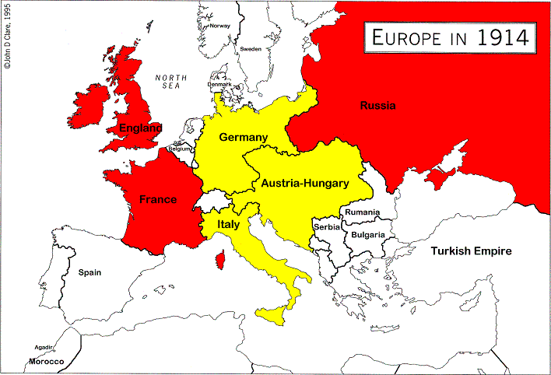
By 1914, Europe had divided into two camps. The Triple Alliance was Germany, Italy and Austria-Hungary.
The Triple Entente was Britain, France and Russia. The alliance between Germany and Austria was natural. Both spoke the same language - German - and had a similar culture. Italy had joined these countries as she feared their power on her northern border. Germany was mainland Europe's most powerful country - so from Italy's point of view, being an ally of Germany was an obvious move. Each member of the Triple Alliance (Germany, Austria and Italy) promised to help the others if they were attacked by another country. The Triple Entente was less structured than the Triple Alliance. "Entente" means understanding and the members of the Entente (Britain, France and Russia) did not have to promise to help the other two if they got attacked by other countries but the understanding was that each member would support the others - but it was not fixed.
France was suspicious of Germany. She had a huge army but a poor navy. Britain had the world's most powerful navy and a small army. France and Britain joining together in an understanding was natural.
Britain was also concerned about Germany because she was building up a new and powerful navy. The inclusion of Russia seemed odd when Russia was so far from France and Britain. However, Russia's royal family, the Romanovs, was related to the British Royal Family. Russia also had a huge army and with France on the west of Europe and Russia on the east, the 'message' sent to Germany was that she was confronted by two huge armies on either side of her borders. Therefore, it was not a good move by Germany to provoke trouble in Europe - that was the hoped for message sent out by the Triple Entente.
WORLD WAR I CAUSES AND OUTCOME
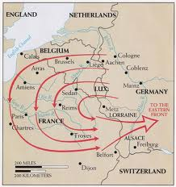
Schlieffen Plan
With Europe so divided, it only needed one incident to spark off a potential disaster. This incident occurred at Sarajevo in July 1914.
World War I was brought about, in many ways, by the ultranationalism of the countries immediately involved. Germany, in particular, had been remodeled under Otto Von Bismarck and was intent on re-gaining the power and prestige it had once enjoyed. When the heir to the Austria-Hungarian throne, Archduke Ferdinand, was assassinated by a Serbian nationalist organization called Blackhand, Austria demanded revenge, asking Germany for their support. Germany, unwisely, offered Austria its full support, which became known as the Blank Cheque Agreement. The Serbs were under Austrian rule, but wanted their sovereignty, and many were willing to resort to violence to get it. Quickly various countries threw their support behind one or the other of these groups: France and Russian supported Serbia, while Germany was behind Austria. The alliance systems already in place almost guaranteed that even more countries would eventually join the feud.
Germany finally decided on the Schlieffen Plan, in which they planned to attack France first, going through neutral Belgium, then go on to attack Russia, which was going through a revolution. Germany thought they could defeat France quickly, then move on to Russia before it was prepared for war.
This didn't happen, because once Germany invaded Belgium, the British got involved along with their vast empire. Before, long countries like Canada were sending troops over to help in the effort. The Western Front, in France, was basically a stalemate for a long time, because soldiers dug trenches in which they lived, and fought from, never making much ground.
The fighting raged on, mainly in Europe, for four long years before Germany finally surrendered and an armistice was signed in 1918.
World War I was the first total war, meaning that most of the countries of the world were involved in it in some way. Civilians as well as soldiers fought, were injured, and were killed. The total deaths of all nations who fought in the war is thought to have been 8.5 million with 21 million being wounded.
Alongside these statistics, was the fact that vast areas of north-eastern Europe had been reduced to rubble. Flanders in Belgium had been all but destroyed with the ancient city of Ypres being devastated. The homes of 750,000 French people were destroyed and the infrastructure of this region had also been severely damaged. Roads, coal mines, telegraph poles had all been destroyed and such a loss greatly hindered the area's ability to function normally.
The victors from World War One were in no mood to be charitable to the defeated nations and Germany in particular was held responsible for the war and its consequences.
TREATY OF VERSAILLES
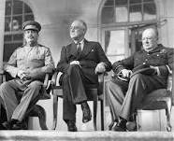
The Treaty of Versailles was the peace settlement signed after World War One had ended in 1918 and in the shadow of the Russian Revolution and other events in Russia. The treaty was signed at the vast Versailles Palace near Paris - hence its title - between Germany and the Allies. The three most important politicians there were David Lloyd George of Britain, Georges Clemenceau of France and Woodrow Wilson of the U.S. Many wanted Germany, now led by Friedrich Ebert, severely punished while others, like Lloyd George, were privately more cautious.
In America, there was a growing desire for the government to adopt a policy of isolation and leave Europe to its own devices. In failing health, Wilson wanted America to concentrate on itself and, despite developing the idea of a League of Nations, he wanted an American input into Europe to be kept to a minimum. He believed that Germany should be punished but in a way that would lead to European reconciliation as opposed to revenge.
He had already written about what he believed the world should be like in his "Fourteen Points" The main points in this document were:
1) no more secret treaties
2) countries must seek to reduce their weapons and their armed forces
3) national self-determination should allow people of the same nationality to govern themselves and one nationality should not have the power to govern another
4) all countries should belong to the League of Nations.
So what exactly did the treaty do to Germany?
The treaty can be divided into a number of sections; territorial, military, financial and general.
Territorial
The following land was taken away from Germany :
Alsace-Lorraine (given to France)
Eupen and Malmedy (given to Belgium)
Northern Schleswig (given to Denmark)
Hultschin (given to Czechoslovakia)
West Prussia, Posen and Upper Silesia (given to Poland)
The Saar, Danzig and Memel were put under the control of the League of Nations and the people of these regions would be allowed to vote to stay in Germany or not in a future referendum.
The League of Nations also took control of Germany's overseas colonies.
Germany had to return to Russia land taken in the Treaty of Brest-Litovsk. Some of this land was made into new states : Estonia, Lithuania and Latvia. An enlarged Poland also received some of this land.
Military
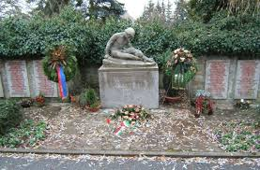
Germany’s army was reduced to 100,000 men; the army was not allowed tanks
She was not allowed an air force She was allowed only 6 capital naval ships and no submarines The west of the Rhineland and 50 kms east of the River Rhine was made into a demilitarized zone (DMZ). No German soldier or weapon was allowed into this zone. The Allies were to keep an army of occupation on the west bank of the Rhine for 15 years.
Financial
The loss of vital industrial territory would be a severe blow to any attempts by Germany to rebuild her economy. Coal from the Saar and Upper Silesia in particular was a vital economic loss. Combined with the financial penalties linked to reparations, it seemed clear to Germany that the Allies wanted nothing else but to bankrupt her.
Germany was also forbidden to unite with Austria to form one superstate, in an attempt to keep her economic potential to a minimum.
General
There are three vital clauses here:
1. Germany had to admit full responsibility for starting the war. This was Clause 231 - the infamous "War Guilt Clause".
2. Germany, as it was responsible for starting the war as stated in clause 231, was, therefore responsible for all the war damage caused by the First World War. Therefore, she had to pay reparations, the bulk of which would go to France and Belgium to pay for the damage done to the infrastructure of both countries by the war. Quite literally, reparations would be used to pay for the damage to be repaired. Payment could be in kind or cash. The figure was not set at Versailles - it was to be determined later. The Germans were told to write a blank cheque which the Allies would cash when it suited them. The figure was eventually put at $33 billion- a huge sum of money well beyond Germany’s ability to pay.
3. A League of Nations was set up to keep world peace.
GERMAN REACTION TO TREATY
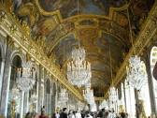
After agreeing to the Armistice in November 1918, the Germans had been convinced that they would be consulted by the Allies on the contents of the Treaty. This did not happen and the Germans were in no position to continue the war as her army had all but disintegrated. Though this lack of consultation angered them, there was nothing they could do about it. Therefore, the first time that the German representatives saw the terms of the Treaty was just weeks before they were due to sign it in the Hall of Mirrors at the Palace of Versailles on June 28th 1919.
There was anger throughout Germany when the terms were made public. The Treaty became known as a Diktat - as it was being forced on them and the Germans had no choice but to sign it. Many in Germany did not want the Treaty signed, but the representatives there knew that they had no choice as German was incapable of restarting the war again.
In one last gesture of defiance, the captured German naval force held at Scapa Flow (north of Scotland) scuttled itself i.e. deliberately sank itself.
Germany was given two choices:
1) sign the Treaty or
2) be invaded by the Allies.
They signed the Treaty as in reality they had no choice. When the ceremony was over, Clemenceau went out into the gardens of Versailles and said "It is a beautiful day".

