The Conscription Crisis in Canada
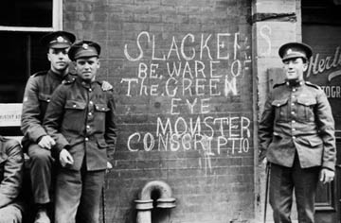
When war erupted in 1914, it caused a patriotic fervor in English Canada. Volunteers flocked to recruiting stations and everyone got into the war effort at home, determined to contribute to the British Empire's battle in Europe. In stark contrast, French Canada felt removed from Britain's plight. They felt little attachment to the Imperial mother country and viewed the Canadian army as an almost entirely English Canadian institution.
French-English tensions were already running high; French Canadians were still enraged that Ontario has banned French as a language of instruction in its schools in 1913.
Of the 400,000 Canadians who volunteered for service in WWI, fewer than one in 20 were French. Of English Canadian volunteers, 70% were recent immigrants from Britain.
French Canada felt confident it could remain removed from the action in Europe because Prime Minister Robert Borden had promised no obligatory military service known as conscription.
By 1917 - after almost three years of fighting - the numbers of dead and wounded mounted overseas. In addition, voluntary enlistment by Canadians dropped drastically as jobs became plentiful at home.
On May 18, 1917, Prime Minister Borden retreated from his earlier promise and introduced a conscription bill, the Military Services Act.
While some English Canadians opposed conscription, nowhere was the outcry greater than in French Canada.
Wilfrid Laurier, now Leader of the Opposition, was also convinced that conscription would tear the country apart.
"Is it not true that the main reason advocated for conscription - not so much publicly as privately, not shouted but whispered - is that Quebec must be made to do her part, and French-Canadians forced to enlist compulsorily since they did not enlist voluntarily?"
Borden ignored the warnings. The Military Service Act was passed in the House of Commons on July 24, 1917, thanks to the support of nearly all English-speaking Members of Parliament, and in spite of the opposition of nearly all French-speaking MPs.
On August 28, conscription became law and was followed by two days of violence in Montreal. But the worst was yet to come. On Easter Monday, April 1, 1918, after days of rioting, Ottawa sent soldiers into Quebec City.
In all, four unarmed civilians were killed and dozens injured. English and French Canada hadn't been so divided since Louis Riel was hanged in 1885.
A few months later - November 11, 1918 - the war ended but the fallout of the conscription issue would continue long after. For many years the Conservative Party, which had brought in conscription, found it hard to get votes in Quebec.
The conscription crisis stuck in the minds of French Canadians in the decades to come. The memories fueled the flames of growing French nationalist passions and created a permanent wedge in Canada's linguistic divide.
