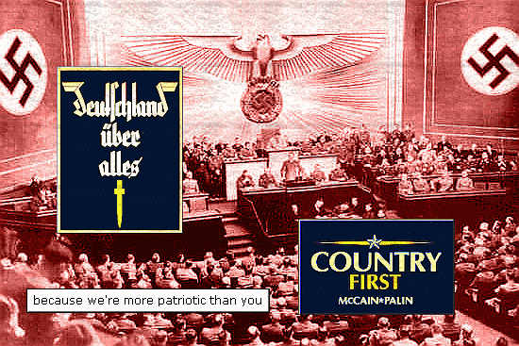

What is Ultra Nationalism?
Ultra nationalism is defined as an extreme form of nationalism or extreme devotion to the interests of a nation. At some point, ultranationalist changes from valuing their own country to directing hostility toward other nations.

Russian Ultranationalists.
Drastic economic and social change resulting in unemployment can cause ultra nationalism.
Example Joseph Stalin
Joseph Stalin, a communist, became the leader of the former Soviet Union in 1922. Stalin’s ultranationalist acts included confiscating land owned by farmers, and creating collective farms. Anyone who objected to his ways were killed or sent to labor camps in Siberia or Central Asia. The treatment of Ukrainians was particularly cruel. When farmers refused to give up craps, they were confiscated, resulting in 10 million Ukrainians dying in the 1930’s.
Propaganda is defined as publicity to promote something: information put out by an organization or government to promote a policy, idea, or cause. Propagandists will call their opponents names, play down failures and defeats, use respected symbols to appeal to people’s values and beliefs, appeal to peoples fears.

HOW DOES ULTRANATIONALISM DEVELOP?
Ultra nationalization develops during events such as crisis, charismatic leaders and national traditions and myths that promote superiority.
Germany
The Great Depression of the 1930’s caused an economic crisis throughout the world. Germany was hit especially hard. Germany owed money to the United States, after the United States gave money to help Germany rebuild itself. During the 1920’s Germany suffered from extreme inflation. German money increased nearly 100 times. Prosperity depended on trade with other countries. To protect their own countries other countries would not trade with Germany, many people were laid off. Standard of living was destroyed. Germany looked for a strong leader and Adolf Hitler was elected president.
Japan
During World War I Japan supported the Allies, then after the war, Japanese exports to Europe and the United States increased. The Great Depression caused many people to lose their jobs. Massive failure in the rice crops in 1932 brought Japan to a famine. Japanese ultranationalists blame the politicians for the crisis. To obtain raw material Japan invaded north-eastern China in 1931.
Charismatic Leaders
Charismatic leaders emerged in USSR, Italy, Germany and Japan. This promoted enthusiasm and devotion in their followers and any opposition was stopped with deadly force.
Hitler and Germany
Adolf Hitler said he would make Germany a leading country by not recognizing the Treaty of Versailles, rebuilding armed forces and reclaiming lost territories, and restoring superiority of the “Aryan race”. Propaganda was used in all aspects of the media to promote ultra nationalism.
Hirohito and Tojo in Japan
Hirohito was not involved in politics, he was a commander of the Japanese armed forces. He made most of the decisions for Japan during World War II. Tojo became the Prime Minister of Japan in 1941, and transformed Japan into a military dictatorship. He promised Japan would dominate Asia.
Ultra nationalistic views in Germany
starting in elementary school, people were taught that ultra nationalism was necessary. Nazi’s needed to rid the land of socialists, Jews, Romas, homosexuals and people with disabilities. Hitler passed laws to remove the basic rights of Jews.
Ultra nationalistic views in Japan
Ultranationalists were gaining more and more power as the country prepared for war. The ideas of Nazi Germany were praised.
How have people responded to ultra nationalism?
People have found it difficult to deal with ultra nationalism in peaceful ways due to the fact that ultra nationalism uses propaganda and hatred to reach their goal.
Appeasement is defined as giving into demands. After World War I and the Great Depression, many countries found avoiding another world war to be a number one priority.
League of Nations
After World War I the League of Nations was created to maintain peace. If one country were to invade another they could
Order invaders to leave.
Impose sanctions.
Use military force.
When Japan invaded China, China turned to the League for help. Japan resigned form the League in 1933. After this the League didn’t know what to do, so they did nothing.
Ethiopia
Italy suffered many of the same problems and Germany after the war. Benito Mussolini, and ultranationalist, became the Prime Minister in 1922, he ruled through fear. Italy fought on the side of the Allies in World War I, and was angry when the Treaty of Versailles did not give Italy control of Ethiopia. In October of 2095 Mussolini ordered Italy to invade Ethiopia. Both countries were League members. In June of 1936, Haile Selassie, the Ethiopian emperor traveled to League headquarter to plead for help. The league ordered sanctions against Italy, these failed because countries ignored them. Britain and France were scared to drive Mussolini into alliance with Germany and Japan. Therefore Ethiopia received no help.
War as a response to ultra nationalism
On September 1, 1939, Hitler invaded Poland. Britain and France realized that appeasement had failed, and declared was on September 3rd. On September 10, Prime Minister King announced that Canada too was involved in the war. Canadians were told that Germany was the evil enemy. They were fighting for the freedom of mankind.
Conscription is defined as compulsory military service.
Francaphones opposed to conscription because they feared they would lose their farms. English was the language of the military. During World War I people of Japanese, German and Ukrainian heritage were interned. During World War II they were discriminated against. In 1942, Japanese Canadians who live within 160 kilometers of the Canadian Pacific Coast were put in internment camps. The government seized Japanese-owned homes; property and businesses, and then sold them to get money to fund keeping people in camps.

