Chapter 7: Crimes Against Humanity
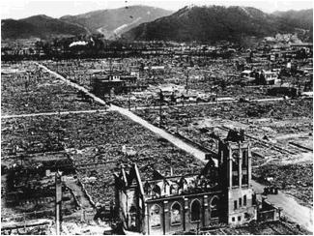

What are crimes against Humanity?

People’s loyalty can help their nation grow and prosper. But when nationalism becomes extreme, it can turn into ultranationalism. When this happens people may commit crimes against humanity.

“The Disappeared” of Argentina
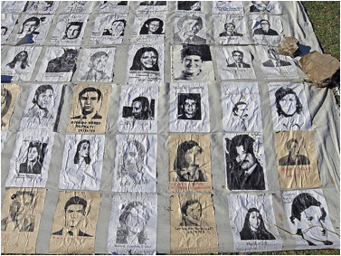

The Nanjing Massacre
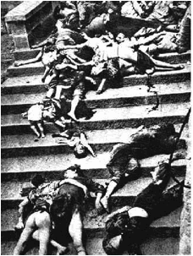

Apartheid
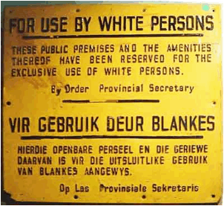

Rwanda
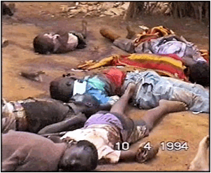

Naming the Crimes:

Crimes against Humanity refers to widespread or systematic attacks against a civilian population – murder, enslavement, deportation, imprisonment, torture, sexual violence, kidnapping, persecution, and apartheid.

Genocide refers to the killing of members of a national, ethnic, racial, or religious group; or deliberately inflicting on the group conditions of life calculated to bring about its physical destruction.

War Crimes refers to the willful killing, torture, or inhumane treatment; willfully causing great suffering; and intentionally directing attacks against the civilian population or against those involved in humanitarian or peacekeeping missions.

From Ultranationalism to Crimes against Humanity

Ultranationalists start by persecuting members of minority groups. Propaganda is used to instill hatred. They separate members of a minority group and treat them as less than human. The minority group is blamed for the problems of society.

Laws are passed limiting the rights of the minority group. The government may pass laws that:
- Restrict freedom of speech
- Demand identification
- Deny education and employment
- Restrict movement
- Deny human rights
- Deny human rights – belongings may be taken, minority may be imprisoned, tortured or murdered.

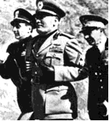
(Benito Mussolini, Italy)
Ultranationalism in Italy, Germany and Japan
Nationalism, the most important single cause of World War 1, became even more potent and poisonous in the 1920s and 1930s, leading to a second world war many times more costly and horrifying than the struggle of 1914 to 1918. In Italy and Germany extreme nationalism was the driving force behind right-wing, anti-democratic movements personified by Benito Mussolini, whose Fascists seized power in Italy in 1922, and Adolf Hitler, whose Nazis took over Germany in 1933. In Japan ultranationalists never did away with the limited democracy established by the 1890 constitution, but in the 1930s their views inspired millions and became the dominant belief within the Japanese military.
These three nations in which nationalism ran wild were similar in several respects. All three were recent creations: Italy gained national Unity between 1859 and 1870, Germany achieved the same in 1871, and Japan emerged from its feudal past only after the Meiji Restoration of 1868. All three had weak parliamentary governments and lacked experience in democratic politics. All three resented their treatment after World War I: the Germans were humiliated by the Versailles Treaty, while the Italians and Japanese were insulted by the refusal of Great Britain and France to recognize all their territorial claims. Finally, all three faced severe economic problems after World War I that extreme nationalists claimed could be solved by expansion and conquest.
Although ultranationalism in each state differed in certain respects, it had the same tragic result: it led all three nations into catastrophic wars. After conquering Manchuria in 1931, invading China in 1937, attacking the United States at Pearl Harbor in 1941, and expanding into Southeast Asia, Japan conceded defeat only when atomic bombs devastated Hiroshima and Nagasaki in August 1945. Germany launched World War II in Europe with its attack on Poland in September 1939, but after conquering much of western Europe and invading the Soviet Union in 1941, its armies were steadily pushed back until the leaders of a devastated land surrendered in May 1945. Italy entered World War II on the side of Germany in 1940, but its armies performed poorly, and only massive support from Nazi Germany prevented its rapid collapse. Anti-Fascists captured Mussolini and shot him without trial on April 28, 1945, just a few days before Adolf Hitler committed suicide in his bunker under the rubble of what had been Berlin.
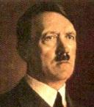
(Adolf Hitler, Germany)

