Kamikaze Pilots

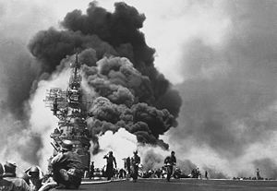

Suicide warfare in World War 2
Japan's Kamikaze pilots and their suicide attacks on American warships in the last year of World War 2, remain one of the most terrorizing memories of this war. Kamikaze pilots would attempt to intentionally crash their aircraft—often laden with explosives, bombs, torpedoes and full fuel tanks—into Allied ships, committing suicide but causing much damage to the enemy.
.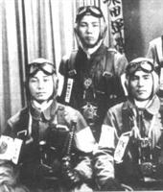
By 1945 it was apparent that Japan was losing the War in the Pacific. As a last ditch effort to turn around their flagging fortunes, the Japanese revived the name Kamikaze and applied it to the suicide missions of their air force. Japanese Vice Admiral Takashiro Ohnishi had noted that the most effective way to inflict damage to warships of the allies was to crash planes into them. He pointed out that one accidental crash could do more damage than ten planes firing machine guns. It was decided that pilots would henceforth purposely crash their planes, which were to be loaded with half a ton of explosives, into enemy warships.
The idea of suicide as a part of national military policy was completely new in the history of warfare. The surprise attacks were to take the Americans completely by surprise. They were bewildered by the Japanese suicide missions, completely unable to comprehend the mentality behind them.
The fact they were to go on suicide missions was accepted without question by the Japanese pilots. All newly conscripted soldiers into the Japanese Armed Forces were indoctrinated with the following five point oath:
(1) A soldier must make loyalty his obligation
(2) A soldier must make propriety his way of life
(3) A soldier must highly esteem military valor
(4) A soldier must have a high regard for righteousness
(5) A soldier must live a simple life

