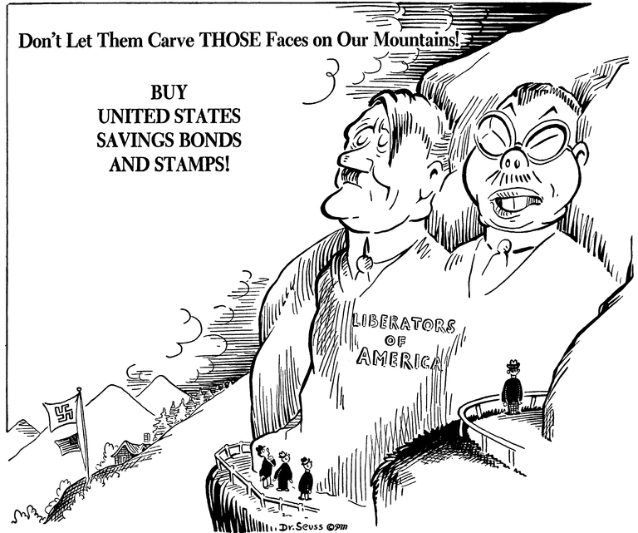
WHAT IS PROPAGANDA?
Propaganda is a specific type of message presentation with a specific purpose. Even if the message gives true information, it may be one-sided and fail to paint a complete picture. Propaganda was widely used by ultranationalists like Hitler and Mussolini, but has also been used by democratic nations and widely in advertising.
Have you ever been convinced to buy a product just because the advertisement makes it sound so good, only to be disappointed with it once you bought it? This is a general type of propaganda.
Propaganda shares many techniques with advertising or public relations; in fact, advertising and PR can be said to be propaganda promoting a commercial product. However, the term usually refers to political or nationalist messages. It can take the form of leaflets, posters, TV broadcasts or radio broadcasts.
Propaganda refers to deliberately false or misleading information that supports a political cause or the interests of those in power. Propaganda is a mighty weapon in war. In this case its aim is usually to make the enemy seem less human, and to create hatred against a special group. The technique is to create a false image in the mind.
Below are some techniques for generating propaganda:
Appeal to fear: Appeal to fear seeks to build support by creating fear in the general population - for example Joseph Goebbels exploited Theodore Kaufman's Germany Must Perish! to claim that the Allies sought the extermination of the German people.
Appeal to authority: Appeal to authority cites prominent figures to support a position idea, argument, or course of action.
Bandwagon: Bandwagon-and-inevitable-victory appeals attempt to persuade the target audience to take a course of action "everyone else is taking." "Join the crowd." This technique reinforces people's natural desire to be on the winning side. This technique is used to convince the audience that a program is an expression of an irresistible mass movement and that it is in their interest to join. "Inevitable victory" invites those not already on the bandwagon to join those already on the road to certain victory. Those already, or partially, on the bandwagon are reassured that staying aboard is the best course of action.
Obtain disapproval: This technique is used to get the audience to disapprove an action or idea by suggesting the idea is popular with groups hated, feared, or held in contempt by the target audience. Thus, if a group which supports a policy is led to believe that undesirable, subversive, or contemptible people also support it, the members of the group might decide to change their position.
Glittering generalities: Glittering generalities are intensely emotionally appealing words so closely associated with highly valued concepts and beliefs that they carry conviction without supporting information or reason. They appeal to such emotions as love of country, home; desire for peace, freedom, glory, honor, etc. They ask for approval without examination of the reason. Though the words and phrases are vague and suggest different things to different people, their connotation is always favorable: "The concepts and programs of the propagandist are always good, desirable, virtuous."
Rationalization: Individuals or groups may use favorable generalities to rationalize questionable acts or beliefs. Vague and pleasant phrases are often used to justify such actions or beliefs.
Intentional vagueness: Generalities are deliberately vague (unspecific) so that the audience may supply its own interpretations. The intention is to convince the audience by use of undefined phrases, without analyzing their validity or attempting to determine their reasonableness or application.
Transfer: This is a technique of projecting positive or negative qualities (praise or blame) of a person, entity, object, or value (an individual, group, organization, nation, patriotism, etc.) to another in order to make the second more acceptable or to discredit it. This technique is generally used to transfer blame from one member of a conflict to another. It evokes an emotional response which stimulates the target to identify with recognized authorities.
Oversimplification: This is used to provide overly simple answers to complex social, political, economic, or military problems.
Common man: The "plain folks" or "common man" approach attempts to convince the audience that the propagandist's positions reflect the common sense of the people. It is designed to win the confidence of the audience by communicating in the common manner and style of the audience. Propagandists use ordinary language and mannerisms (and clothes in face-to-face and audiovisual communications) in attempting to identify their point of view with that of the average person.
Testimonial: Testimonials are quotations, in or out of context, especially used to support or reject a given policy, action, program, or personality. The reputation or the role (expert, respected public figure, etc.) of the individual giving the statement is exploited. The testimonial places the official sanction of a respected person or authority on a propaganda message. This is done in an effort to cause the target audience to identify itself with the authority or to accept the authority's opinions and beliefs as its own.
Stereotyping or Labeling: This technique attempts to arouse prejudices in an audience by labeling the object of the propaganda campaign as something the target audience fears, hates, loathes, or finds undesirable.
Scapegoating: Assigning blame to an individual or group that isn't really responsible, thus alleviating feelings of guilt from responsible parties and/or distracting attention from the need to fix the problem for which blame is being assigned.
Virtue words: These are words in the value system of the target audience which tend to produce a positive image when attached to a person or issue. Peace, happiness, security, wise leadership, freedom, etc., are virtue words.
Slogans: A slogan is a brief striking phrase that may include labeling and stereotyping. If ideas can be sloganized, they should be, as good slogans are self-perpetuating memes.

