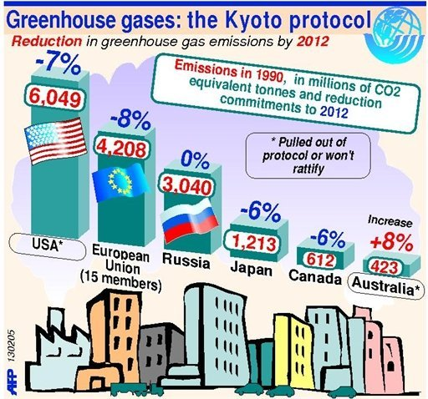
Canada quits Kyoto climate pact

December 12, 2011
Canada officially renounced the expiring Kyoto Protocol on Monday, a day after international negotiators agreed to extend the treaty's limits on carbon emissions blamed for a warming climate.
Environment Minister Peter Kent said Ottawa would keep working to reduce its greenhouse gas emissions and help negotiate a new framework for a global pact.
But in a statement to reporters on his return from last lesson's climate conference in South Africa, Kent said that for Canada, Kyoto "is in the past."
Prime Minister Stephen Harper's Conservative government has long opposed the Kyoto protocol and has refused to implement it since taking office in 2006. Ahead of the decision, the opposition New Democratic Party accused his government of "standing up for big polluters" at the expense of ordinary Canadians and risking the country's reputation by abandoning the 1997 treaty.
Kent said Kyoto's goals were unworkable because the United States and China -- the world's two largest sources of carbon emissions -- never agreed to Kyoto, and that a new pact is needed to address emissions from rapidly growing economies including those of China, Brazil and India.
The government announced in 2010 that it would fall well short of the treaty's target of a 6% cut in emissions below 1990 levels by 2012. Kent said the previous government signed onto the treaty "without any regard to how it would be fulfilled," and that Canadians faced "radical" cuts or financial penalties equivalent to $1,600 per family as a result.
So what does all of this mean? On its face, not much, as Canada isn't a huge emitter of greenhouse gases (though its contribution is growing). But it's a big blow to the Kyoto Protocol and could lead other countries facing their own economic problems to follow suit, emasculating the only binding international emissions reduction agreement ever ratified. The Durban talks mapped out a path to internationally binding emissions reduction standards, but those won't be agreed upon until 2015 and likely not implemented until 2020. In the meantime, Kyoto is the only tangible set of standards in place.
Nonetheless, Canada is out. "Kyoto is not the path forward for a global solution to climate change," Kent said. "If anything it's an impediment."

