FIRST NATIONS POLITICS
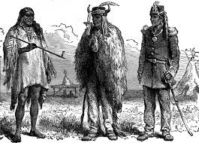
Although Canada's Native groups live in many places throughout the country, they are another disaffected and often alienated group. As with Quebecois and Western alienation, history provides answers to why Native groups feel distanced from other Canadians.
Canada's Native Peoples are a diverse group representing many different cultures and languages. Today, they make up about seven percent of Canada's population and range from the Nootka fishermen and seal-hunting Inuit to Iroquoian farmers in the St. Lawrence Valley. With enormous cultural and linguistic differences, plus separation across Canada's vast landscape, Native Peoples have not been united in their efforts to find a place in Canadian society. Just as forming policies that include all regional demands is difficult, political programs which include all Native groups are filled with problems. The lack of unity has made Native political efforts to express alienation difficult to coordinate.
Initially, the first contacts that native Peoples had with Europeans were friendly and open. Native groups were treated as independent nations and dealt with by military diplomats. European expansion across North America, as well as their growing intolerance of non-technological societies, led to a different tone in the treatment of Native Peoples.
In 1830, the military diplomats were replaced by a civilian department of Indians Affairs. The Indian Department took a paternalistic (fatherly) tone toward Native Peoples, and settled Native groups onto reserves to make way for more European settlers. The attitude by European governors was that native societies needed European help to survive and modernize. Native Peoples were strongly encouraged to assimilate into European lifestyles.
After Confederation, little changed in the administration of Native affairs in Canada. Treaties continued to dictate Native relations with the Canadian government.
In 1969, the government's White Paper proposed to abolish the Indian Act and dismantle the Department of Indian Affairs. Native concerns would then become a provincial responsibility. Native protests over this proposal made the federal government back down. With this proposal, many Native groups feared an even greater fragmentation of their ability to lobby for Native Peoples' concerns, and a loss of status as a distinct group in Canada. Protests over the White Paper increased Native political activity and Native efforts to form political organizations.
Because Native Peoples did not get the federal vote until 1960, Native groups did not have political traditions that fit well with European systems. Initial attempts to form European-style political groups were often short-lived. The National Indian Brotherhood became the Assembly of First Nations in 1980, with 90% of Native chiefs across Canada represented. The Native Council of Canada represents Metis and non-status Native Peoples, and the Inuit Tapirisat represents Canada's Inuit peoples. In recent years, Native groups have quickly acquired politically savvy, particularly in the use of the media to bring attention to their concerns.
Economic concerns have led the way for political interaction. Bands negotiated with the government over land claims and entitlements, pointing out that treaties entitle them to certain lands and the resources that exist within them. These claims were negotiated using comprehensive and specific claim policies. Comprehensive claims are based on the idea of continuing Native title that has not been dealt with by treaty or other legal means. Specific claims relate to the wrongdoing by government over land and other assets. Settlements have been made with a variety of Native bands including the Cree, Naskapi, the Inuit of Northern Quebec, and the Inuvialuit of the Western Arctic.
Beginning in the 1970s and 80s, federal policy changed to give Native Peoples more control over their own affairs. Recognition grew that Native groups had been successfully self-governing long before European intervention. Programs became more locally oriented, and bands developed the administrative skills to oversee more of their own affairs.
The Constitution Act of 1982 recognized existing Native and treaty rights: promised a series of First Ministers Conferences on self-government and other Native issues, and defined the country's Native Peoples as Indians, Inuit and Metis.
government approved a "two-track" approach for Native self-government. One track was concerned with efforts to reach a constitutional amendment on Native self-government. The other track was to provide Native bands with the means to administer their own programs.
In 1985, a group of New Brunswick Native women took Canada to the UN court to protest a clause in the Indian Act which forced Native women to give up their legal status as Indians if they married a non-Native man. The UN ruled against Canada. Soon after the ruling, a bill which amended the discriminatory clause of the Indian Act, was passed by the Canadian parliament.
In 1990, Native issues dominated Canadian news. A Native Member of the Legislative Assembly in Manitoba, Elijah Harper, became a hero to his people during the debate on the Meech Lake Accord. Many Natives opposed the Accord because they felt it would slow efforts to reform the current system dealing with Native issues in Canada. When the Accord was to be ratified in the Manitoba Legislature, Harper, brandishing an eagle feather symbolizing peace and strength, and a rule book, stated his opposition. Using the rules of the Legislature, he was therefore able to prevent the Accord from passing.
PROFILE
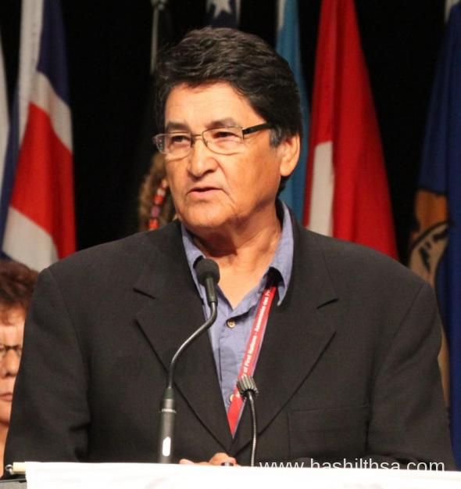
OVIDE MERCREDI (2008)

Mercredi, the National Chief of the Assembly of First Nations is from the Cree Nation and was born in Grand Rapids, Manitoba in 1946. Mercredi studied sociology and anthropology at the University of Manitoba prior to being admitted to the college of law there. Upon graduation, he worked in the northern Manitoba legal system and for a variety of Native political organizations. In 1989, he was elected as the Manitoba chief to the AFN. In 1991 he was elected National Chief, relelected in 1994 and served until 1997. In his second term as National Chief, Mercredi continued to represent the AFN, which is the representative body for over one million status Indians from 633 First Nations across Canada.
Mercredi's primary responsibility as National Chief was to protect and maintain First Nations collective Treaty and Aboriginal Rights in Canada and around the world. His efforts were focused on the implementation of the inherent right of self-government and treaties and advocating for the need to improve the social and economic conditions in First Nations communities.

